|  |  |
| --- | --- |
|  | **FPT ACADEMY INTERNATIONAL**  **FPT – APTECH COMPUTER EDUCATION** |

|  |
| --- |
| **TRANSLATE THIS** |
| TỪ ĐIỂN CÁ NHÂN |

|  |  |  |
| --- | --- | --- |
| **Supervisor.** | **Lê Mộng Thúy** | |
| **Batch.** | **T1.2303.M0** | |
| **Group.** | **01** | |
| **Serial No.** | **Student Name** | **Enrollment Number** |
| **1** | **Vũ Minh Tuấn** | **Student1459120** |
| **2** | **Bùi Thị Nhung** | **Student1459130** |
| **3** | **Trương Nguyễn Quang Huy** | **Student1468180** |

**Month 01 Year 2024**

**TABLE OF CONTENTS**

**REVIEW 1** 2

❖ **ACKNOWLEDGE** 2

❖ **INTRODUCTION** 2

❖ **PROBLEM DEFINITION** 2

❖ **CUSTOMER’S REQUIREMENTS SPECIFICATIONS (CRS)** 3

❖ **TASK SHEET REVIEW 1** 5

**REVIEW 2** 6

❖ **ARCHITECTURE AND DESIGN OF THE PROJECT** 6

❖ **USE CASE** 7

❖ **DATA FLOW DIAGRAM (DFD)** 19

❖ **ENTITY PROPERTIES** 27

❖ **ENTITY RELATIONSHIP DIAGRAM (ERD)** 29

❖ **TABLE DESIGN** 30

**REVIEW 3** 34

❖ **APPLICATION MAP** 34

❖ **TRANSLATE THIS** 34

❖ **TASK SHEET REVIEW 3** 56

# **REVIEW 1**

## **ACKNOWLEDGE**

We would like to extend our heartfelt appreciation to all those who have provided valuable support during the development of our Translate This Dictionary project.

First and foremost, we would like to express our sincere gratitude to our dedicated instructor, Ms. Le Mong Thuy. Her insightful suggestions and words of encouragement not only helped us overcome technical challenges but also provided us with the confidence to tackle psychological obstacles. Without her guidance, our project would not have achieved the level of success it has today.

Secondly, we would like to express our deep appreciation to the Project Team at the Head Office. Their unwavering support and the opportunity they provided us to apply our learning into practical implementation have been invaluable. We are confident that the experiences gained from this project will greatly benefit our future careers in the field.

Thirdly, we would like to acknowledge and thank all the staff members of our center. Their collaboration, not only in allowing us to work with them on this project but also for their continuous support and encouragement throughout the process, has been instrumental in our success.

Lastly, we would like to express our personal gratitude to our fellow classmates and team members. Their open and enthusiastic support has been truly invaluable. Their willingness to lend a helping hand and work together has made this journey enjoyable and rewarding.

Building the Translate This Dictionary project has been a collaborative effort, and we would like to express our sincere appreciation to everyone involved. The unwavering support, guidance, and encouragement we received have helped us overcome technological challenges and bring this project to fruition. We are grateful for the opportunity to apply our knowledge and skills to create a successful movie website.

## **INTRODUCTION**

This Translate This Dictionary project was created to provide a personal dictionary application to search vocabulary information online and offline methods. Users can save online search results to an offline database of dictionaries and edit them according to their needs. The project utilizes the Java and JavaFX to ensure efficient development and a robust user experience.

*For Users:*

1. Dictionary search: Users can search for vocabulary information provided by Google Translate through online methods or provided by the dictionary database through offline methods.
2. Data search and modify: Users can directly search for vocabulary information in the database of dictionaries, and view and edit them according to their needs.
3. Vocabulary learning: Users can also learn to memorize new vocabulary through a word-guessing game.

## **PROBLEM DEFINITION**

After analyzing the project specifications for Translate This Dictionary, and meeting the user demand effectively, we have concluded that addressing the following features will yield the best result.

## **CUSTOMER’S REQUIREMENTS SPECIFICATIONS (CRS)**

PROJECT OBJECTIVE:

This project aims to design a user-friendly interface that enables easy search vocabulary, access to it, and modify information without confusion or complexity. Information about vocabulary is displayed comprehensively and consistently, including information about pronouncing, types, and definitions. The goal of the project is to provide a user-friendly dictionary that can edit any information according to need.

*INPUT OF THE SYSTEM*

User need to provide:

• Mode selection online or offline.

• Translating selection from English to Vietnamese or from English to English.

• Vocabulary for searching information.

• Information about vocabulary such as names, and types to search in the database

• Selected vocabulary for deletion and editing

• Vocabulary details like name, pronunciation, type, definition to add or edit.

• Words which are guessed by pressing the corresponding buttons.

• Choose whether to complete or skip the question.

*OUTPUT OF THE SYSTEM*

Application will provide:

• Vocabulary information from Google Translate in online mode and application database in offline mode

• The definition of the word entered by the user is translated into Vietnamese or English.

• Detailed information about vocabulary such as name, pronunciation, type, and definition after searching in the database

• Vocabulary delete and edit after selected.

• New vocabulary or changed information like name, pronunciation, type, and definition will be updated in the database after adding or editing.

• The result is based on the button the user pressing.

• Game points will be calculated based on the user's selection.

*HARDWARE/ SOFTWARE REQUIREMENTS*

*For usage:*

|  |  |  |  |
| --- | --- | --- | --- |
|  | | **Online Mode** | **Offline Mode** |
| **Hardware** | Processor | Intel Core I5 or higher | Intel Core I5 or higher |
| Memory | 8 GB RAM or greater | 8 GB RAM or greater |
| Monitor | Super VGA (1366x768) or higher resolution | Super VGA (1366x768) or higher resolution |
| Modem/ADSL | Internet access is required | None required |
| **Software** | Operation System | Window 10 or higher | Window 10 or higher |
| Software | Java Runtime Environment | Java Runtime Environment |

*For deploying:*

|  |  |  |
| --- | --- | --- |
| **Hardware** | Processor | Intel Core I5 or higher |
| Memory | 8 GB RAM or greater |
| Monitor | Super VGA (1366x768) or higher resolution |
| Modem/ADSL | Internet access is required |
| **Software** | Operation System | Window 10 or higher |
| Software | Simple logging facade |
| ControlsFX |
| SQLite tools |
| Development Software | * Microsoft Windows 10 * SQLite Studio * NetBean * Scene Builder |
| Technology | * Java * JavaFX * CSS * SQLite |

*SCOPE OF WORK*

This application is designed to achieve the following purposes :

• Dictionary: Allows users to translate from English to Vietnamese by using Google Translate in online mode, English to Vietnamese, or English to English by using an application database in offline mode. Users can also add new vocabulary from Google Translate if it is not in the dictionary database or they can update a new definition for it if it is already in the database.

• Database: Displays a vocabulary list and allows users to search for information in the application database through keywords such as name or type. Manage adding, editing, and deleting any of them.

• Vocabulary learning: Supports users to memorize vocabulary in the database through a word guessing game including 20 random questions.

## **TASK SHEET REVIEW 1**

|  |  |  |  |  |  |  |  |  |
| --- | --- | --- | --- | --- | --- | --- | --- | --- |
| **Project: Translate This** | | **Project Name** | **Activity**  **Plan Prepared**  **By** | | **Date of Preparation of Activity Plan:** | | | |
| **Sr./No.** | **Task** | **Actual Start Date** | **Actual Days** | **Team member name** | **Status** |
| 1 | Acknowledgment | Translate This | Tuấn | | 11/Jan/2024 | 1 | Tuấn | Completed |
| 2 | Introduction | 11/Jan/2024 | 1 | Nhung | Completed |
| 3 | Problem Definition | 11/Jan/2024 | 1 | Huy | Completed |
| 4 | Customer Requirement Specification (CRS) | 11/Jan/2024 | 1 | Tuấn | Completed |
| 5 | Scope of Work | 12/Jan/2024 | 1 | Nhung | Completed |
| 6 | Hardware/Software Requirement | 12/Jan/2024 | 1 | Huy | Completed |
| 7 | Task Sheet | 13/Jan/2024 | 1 | Tuấn | Completed |
| Date: 11 – JAN - 2024 | | | | | | | | |
| Signature of Instructor:  Ms. LÊ MỘNG THÚY | | | | Signature of Team Leader:  VŨ MINH TUẤN | | | | |

# **REVIEW 2**

## **ARCHITECTURE AND DESIGN OF THE** **PROJECT**

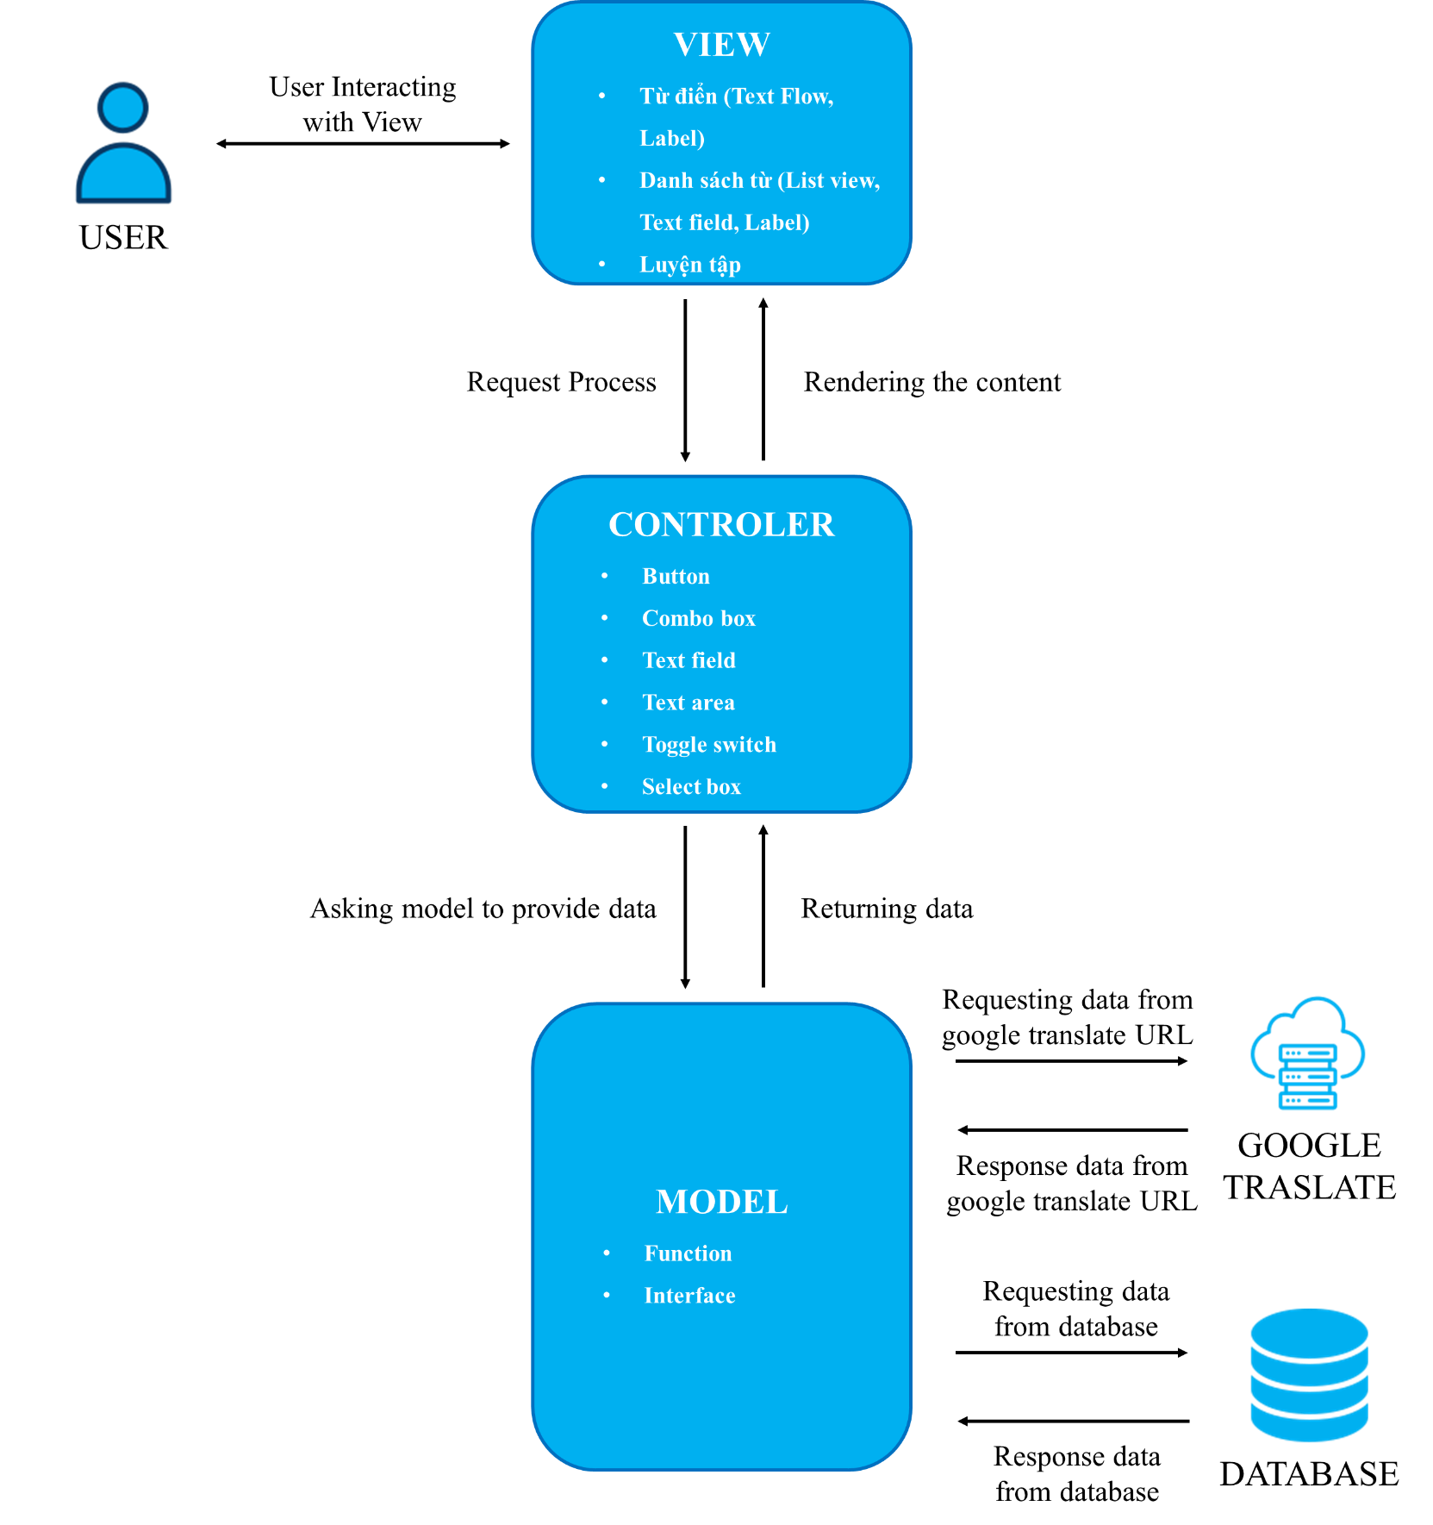

## **USE CASE**

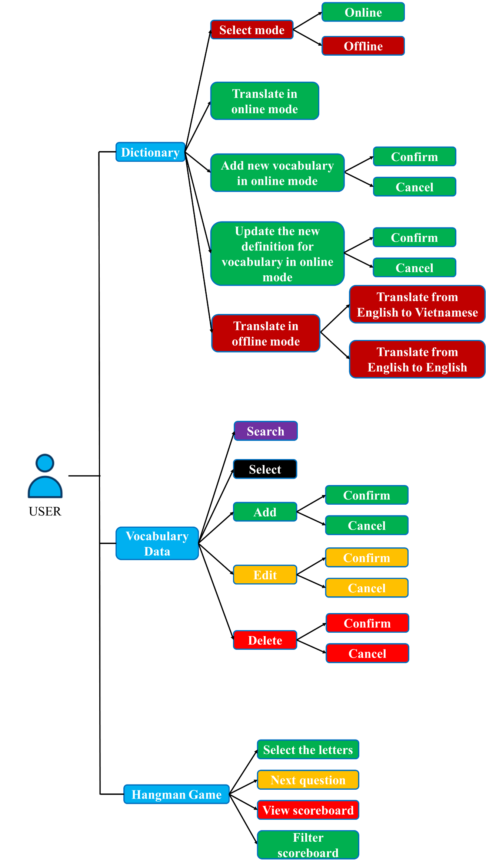

*TRANSLATE*

*Select mode:*

|  |  |  |
| --- | --- | --- |
| **Author** |  | |
| **Use case name** | Select mode | |
| **Actors** | User | |
| **Description** | Users interacts with the toggle switch to select online or offline mode. | |
| **Requirements** | None | |
| **Pre-conditions** | Online mode is only available when having a connection to Google translate URL. | |
| **Post-conditions** | None | |
| **Basic flow** | **User interactions** | **Application responses** |
| User switches to offline mode. | * Application displays a restriction message in offline mode. * Change UI to offline mode. |
| User switches to offline mode. | * Application checks for connection to Google translate URL. If it can't connect, then it will switch back to offline mode * Change UI to online mode |
| **Exceptions** | **User interactions** | **Application responses** |
| User tries to switch to online mode when having no connection available. | Application will check for connection to Google translate URL. If it can't connect, then it will switch back to offline mode. |

*Translate in online mode:*

|  |  |  |
| --- | --- | --- |
| **Author** |  | |
| **Use case name** | Translate in online mode | |
| **Actors** | User | |
| **Description** | User translates word in online mode. | |
| **Requirements** | User enters word to translate. | |
| **Pre-conditions** | Online mode can only translate to other languages due to limitations of Google Translate URL. In this case, the application is set to translate from English to Vietnamese when online. | |
| **Post-conditions** | None | |
| **Basic flow** | **User interactions** | **Application responses** |
| User enters the word to translate and presses the “Dịch” button. | * Application displays the word suggest when the user inputs in the text field if the word exists in the database. * Application displays the word the user just entered and its definition. |
| **Exceptions** | **User interactions** | **Application responses** |
| User inputs text in a non-English language. | Application will display a error message and stop translate function. |
| User inputs word that are longer than 30 characters. | Application will display a error message and stop translate function. |

*Add new vocabulary in online mode:*

|  |  |
| --- | --- |
| **Author** |  |
| **Use case name** | Add new vocabulary in online mode |
| **Actors** | User |
| **Description** | User add new vocabulary in online mode. |
| **Requirements** | The word has been translated. |
| **Pre-conditions** | * Add function is only available in online mode * The vocabulary that user wants to add does not exist in the dictionary's database |
| **Post-conditions** | Success: New vocabulary is added into the database |
| Fail: User can’t add new vocabulary |

|  |  |  |
| --- | --- | --- |
| **Basic flow** | **User interactions** | **Application responses** |
| User presses the “Thêm” từ vựng button. | Application displays a confirmation message. If the user chooses OK, the application will add vocabulary and its definition to the database. If not, the application will cancel the process. |
| **Exceptions** | **User interactions** | **Application responses** |
| The word hasn’t been translated or the text field is empty. | Application will disable the “Thêm” từ vựng button. |
| The vocabulary that the user wants to add exists in the dictionary's database. | Application will switch to the update definition function for vocabulary in the database. |

*Update the new definition for vocabulary in online mode:*

|  |  |  |
| --- | --- | --- |
| **Author** |  | |
| **Use case name** | Update the new definition for vocabulary in online mode | |
| **Actors** | User | |
| **Description** | User update the new definition for vocabulary in online mode | |
| **Requirements** | The word has been translated | |
| **Pre-conditions** | * Update the new definition function is only available in online mode * The definition that user wants to update does not exist in the dictionary's database * The vocabulary that user wants to add exists in the dictionary's database | |
| **Post-conditions** | Success: New definition is updated into the database | |
| Fail: User can’t update new definition | |
| **Basic flow** | **User interactions** | **Application responses** |
| User presses the “Thêm” từ vựng button. | Application displays a confirmation message. If the user chooses OK, the application will update the new definition and its update date to the database. If not, the application will cancel the process. |

|  |  |  |
| --- | --- | --- |
| **Exceptions** | **User interactions** | **Application responses** |
| The word hasn’t been translated or the text field is empty. | Application will disable the “Thêm” từ vựng button. |
| The definition that user wants to update does not exist in the dictionary's database | Application will display a error message. |

*Translate in offline mode:*

|  |  |  |
| --- | --- | --- |
| **Author** |  | |
| **Use case name** | Translate in offline mode | |
| **Actors** | User | |
| **Description** | User translates word in offline mode. | |
| **Requirements** | User enters word to translate. | |
| **Pre-conditions** | Offline mode can only translate from English to Vietnamese or from English to English due to limitations of database. | |
| **Post-conditions** | None | |
| **Basic flow** | **User interactions** | **Application responses** |
| User enters the word to translate and presses the “Dịch” button. | * Application displays the word suggest when the user inputs in the text field if the word exists in the database. * Application displays the entered word again with its characteristics such as pronunciation, word type, definition, and newly updated definition if it exists. |
| **Exceptions** | **User interactions** | **Application responses** |
| User inputs text in a non-English language. | Application will display a error message and stop translate function. |
| User inputs word that are longer than 30 characters. | Application will display a error message and stop translate function. |

*DATABASE*

*Search vocabulary in user database:*

|  |  |  |
| --- | --- | --- |
| **Author** |  | |
| **Use case name** | Search word in database | |
| **Actors** | User | |
| **Description** | User search word in database. | |
| **Requirements** | User provides search phrase. | |
| **Pre-conditions** | None | |
| **Post-conditions** | Success: Display vocabulary that matches search phrase | |
| Fail: No vocabulary is displayed | |
| **Basic flow** | **User interactions** | **Application responses** |
| User interacts with any components of the search bar including selecting dictionary, word name, or word type. | Application shows the list of vocabularies that match the search phrase. |
| **Exceptions** | **User interactions** | **Application responses** |
| The vocabulary that the user wants to search doesn’t exist in the dictionary's database. | Application won’t display anything. |

*Select vocabulary in user database:*

|  |  |
| --- | --- |
| **Author** |  |
| **Use case name** | Select vocabulary in database |
| **Actors** | User |
| **Description** | User select vocabulary in database. |
| **Requirements** | None |
| **Pre-conditions** | None |
| **Post-conditions** | None |

|  |  |  |
| --- | --- | --- |
| **Basic flow** | **User interactions** | **Application responses** |
| User select all | Application selects all currently displayed vocabularies and update their check column in the database to 1. |
| User deselects all | Application deselects all currently displayed vocabularies and update their check column in the database to 0. |
| User selects each vocabulary | Application selects the corresponding vocabularies and update their check column in the database to 1. |
|  | User deselects each vocabulary | Application deselects the corresponding vocabularies and update their check column in the database to 0. |
| **Exceptions** | None | |

*Add new vocabulary into user database:*

|  |  |  |
| --- | --- | --- |
| **Author** |  | |
| **Use case name** | Add new vocabulary into database | |
| **Actors** | User | |
| **Description** | User add new vocabulary into database. | |
| **Requirements** | User provides vocabulary information. | |
| **Pre-conditions** | None | |
| **Post-conditions** | Success: New vocabulary is added into the database | |
| Fail: User can’t add new vocabulary | |
| **Basic flow** | **User interactions** | **Application responses** |
| User presses the “Thêm” button. | Application opens a new window allowing the user to enter the necessary information. |
| User fills in the form. | Application validates inputs. If the input is invalid, the submit button will be disabled. |

|  |  |  |
| --- | --- | --- |
|  | User presses the submit button. | * Application add new vocabulary into database. * Application displays a confirmation message or error message based on the result of the insert status. |
| **Exceptions** | User inputs invalid information or leaves field empty | The application will disable the submit button |

*Delete vocabulary from user database:*

|  |  |  |
| --- | --- | --- |
| **Author** |  | |
| **Use case name** | Delete vocabulary from database | |
| **Actors** | User | |
| **Description** | User deletes vocabulary from database. | |
| **Requirements** | User selects vocabularies to delete. | |
| **Pre-conditions** | None | |
| **Post-conditions** | Success: Delete vocabularies from the database | |
| Fail: User can’t delete vocabularies | |
| **Basic flow** | **User interactions** | **Application responses** |
| User presses the “Xóa” button. | * Application displays a confirmation message with the number of words that will be deleted. If the user chooses OK, the application will delete vocabularies from the database. If not, the application will cancel the process. * Application displays a confirmation message or error message based on the result of the delete status. |
| **Exceptions** | User doesn’t select any vocabulary to delete. | Application will display a error message. |

*Edit vocabulary in database:*

|  |  |  |
| --- | --- | --- |
| **Author** |  | |
| **Use case name** | Edit vocabulary in database | |
| **Actors** | User | |
| **Description** | User edits vocabulary in database. | |
| **Requirements** | User selects vocabulary to edit. | |
| **Pre-conditions** | None | |
| **Post-conditions** | Success: Update vocabulary information in the database | |
| Fail: User can’t update vocabulary information | |
| **Basic flow** | **User interactions** | **Application responses** |
| User presses the “Sửa” button. | Application opens a new window allowing the user to edit vocabulary information. |
| User fills in the form. | Application validates inputs. If the input is invalid, the submit button will be disabled. |
| User presses the submit button. | * Application update new vocabulary information into database. * Application displays a confirmation message or error message based on the result of the update status. |
| **Exceptions** | User doesn’t select any vocabulary to edit. | Application will display a error message. |
| User select more than one vocabulary to edit. | Application will display a error message. |

*Add vocabulary from default data to user data:*

|  |  |  |
| --- | --- | --- |
| **Author** |  | |
| **Use case name** | Add vocabulary from default data to user data | |
| **Actors** | User | |
| **Description** | User add vocabulary from default data to user data. | |
| **Requirements** | None | |
| **Pre-conditions** | None | |
| **Post-conditions** | Success: Insert vocabulary information from default data to user data | |
| Fail: User can’t insert vocabulary information from default data to user data. | |
| **Basic flow** | **User interactions** | **Application responses** |
| User presses the “Thêm từ vựng từ hệ thống” button. | * The application will check if the added vocabulary is already in the data. If it is not in the data, then the vocabulary will be added; otherwise, it will be ignored. * Application displays a confirmation message or error message based on the result of the insert status. |
| All the added vocabulary is already in the data | The application will ignore all of those vocabularies. |

*HANGMAN GAME*

*Select the letters:*

|  |  |
| --- | --- |
| **Author** |  |
| **Use case name** | Select the letters |
| **Actors** | User |
| **Description** | User select the letters to guess the word. |
| **Requirements** | User presses letter button. |
| **Pre-conditions** | None |
| **Post-conditions** | Success: Correct letters will be displayed in the answer |
| Chosen letter will be hidden |

|  |  |  |
| --- | --- | --- |
| **Basic flow** | **User interactions** | **Application responses** |
|  | User presses letter button. | * Application checks whether the letter which user just interacted with matches any letter in the answer. * If the letter matches, it will be displayed on the answer and the chosen letter will be hidden. * If the letter doesn't match, it will be hidden, the user will lose one turn. * The question will be completed when the user guesses all the characters correctly or user has no more turns to play. * Application will display a congratulatory or failure message based on the final result of the current question. |
| **Exceptions** | User doesn’t select any letter. | Application will do nothing. |
| User guessed wrong | Application will deduct one turn of play. |
| User guessed wrong three times | Application will end the current question, move on to the next, and display a failure message. |

*Next question:*

|  |  |
| --- | --- |
| **Author** |  |
| **Use case name** | Next question |
| **Actors** | User |
| **Description** | User moves on to the next question. |
| **Requirements** | User presses “Tiếp tục” button. |
| **Pre-conditions** | None |
| **Post-conditions** | None |

|  |  |  |
| --- | --- | --- |
| **Basic flow** | **User interactions** | **Application responses** |
| User presses “Tiếp tục” button. | * Application checks whether the question was completed. * If the question is completed, the application updates the player's score on the current question and moves on to the next question. * If the question isn't completed, the application sets the player's score to zero for the current question and moves on to the next question. |
| **Exceptions** | User doesn’t press “Xác nhận” button when the game end. | Application won’t move on to the next question. |
| User has not yet guessed all the letters. | Application sets the player's score to zero for the current question and moves on to the next question. |

*View scoreboard:*

|  |  |  |
| --- | --- | --- |
| **Author** |  | |
| **Use case name** | View scoreboard | |
| **Actors** | User | |
| **Description** | User views scoreboard. | |
| **Requirements** | None | |
| **Pre-conditions** | The user has answered 20 questions. | |
| **Post-conditions** | None | |
| **Basic flow** | **User interactions** | **Application responses** |
| The user has answered 20 questions. | The response displays the scoreboard. |
| **Exceptions** | None | |

## **DATA FLOW DIAGRAM (DFD)**

*LEVEL 0:*

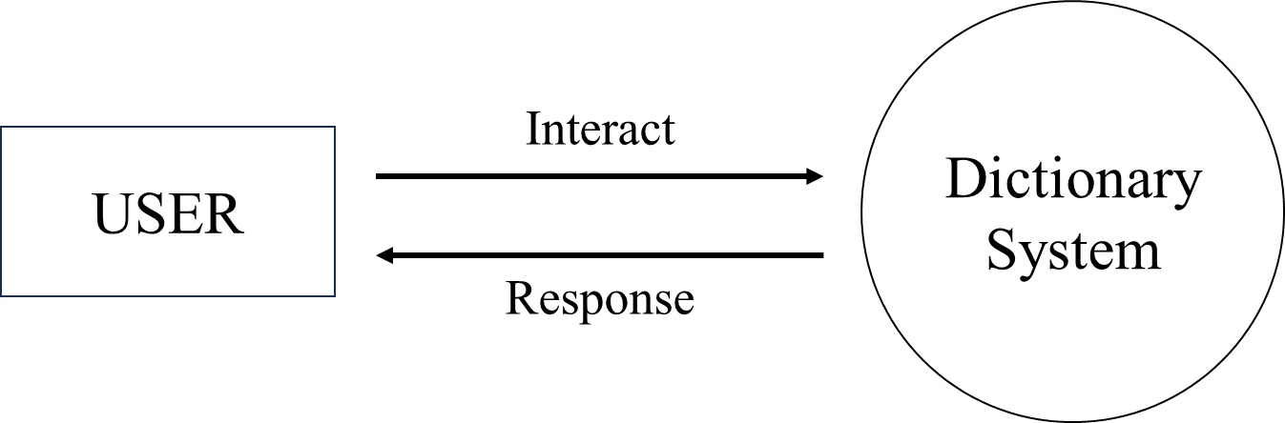

*LEVEL 1:*

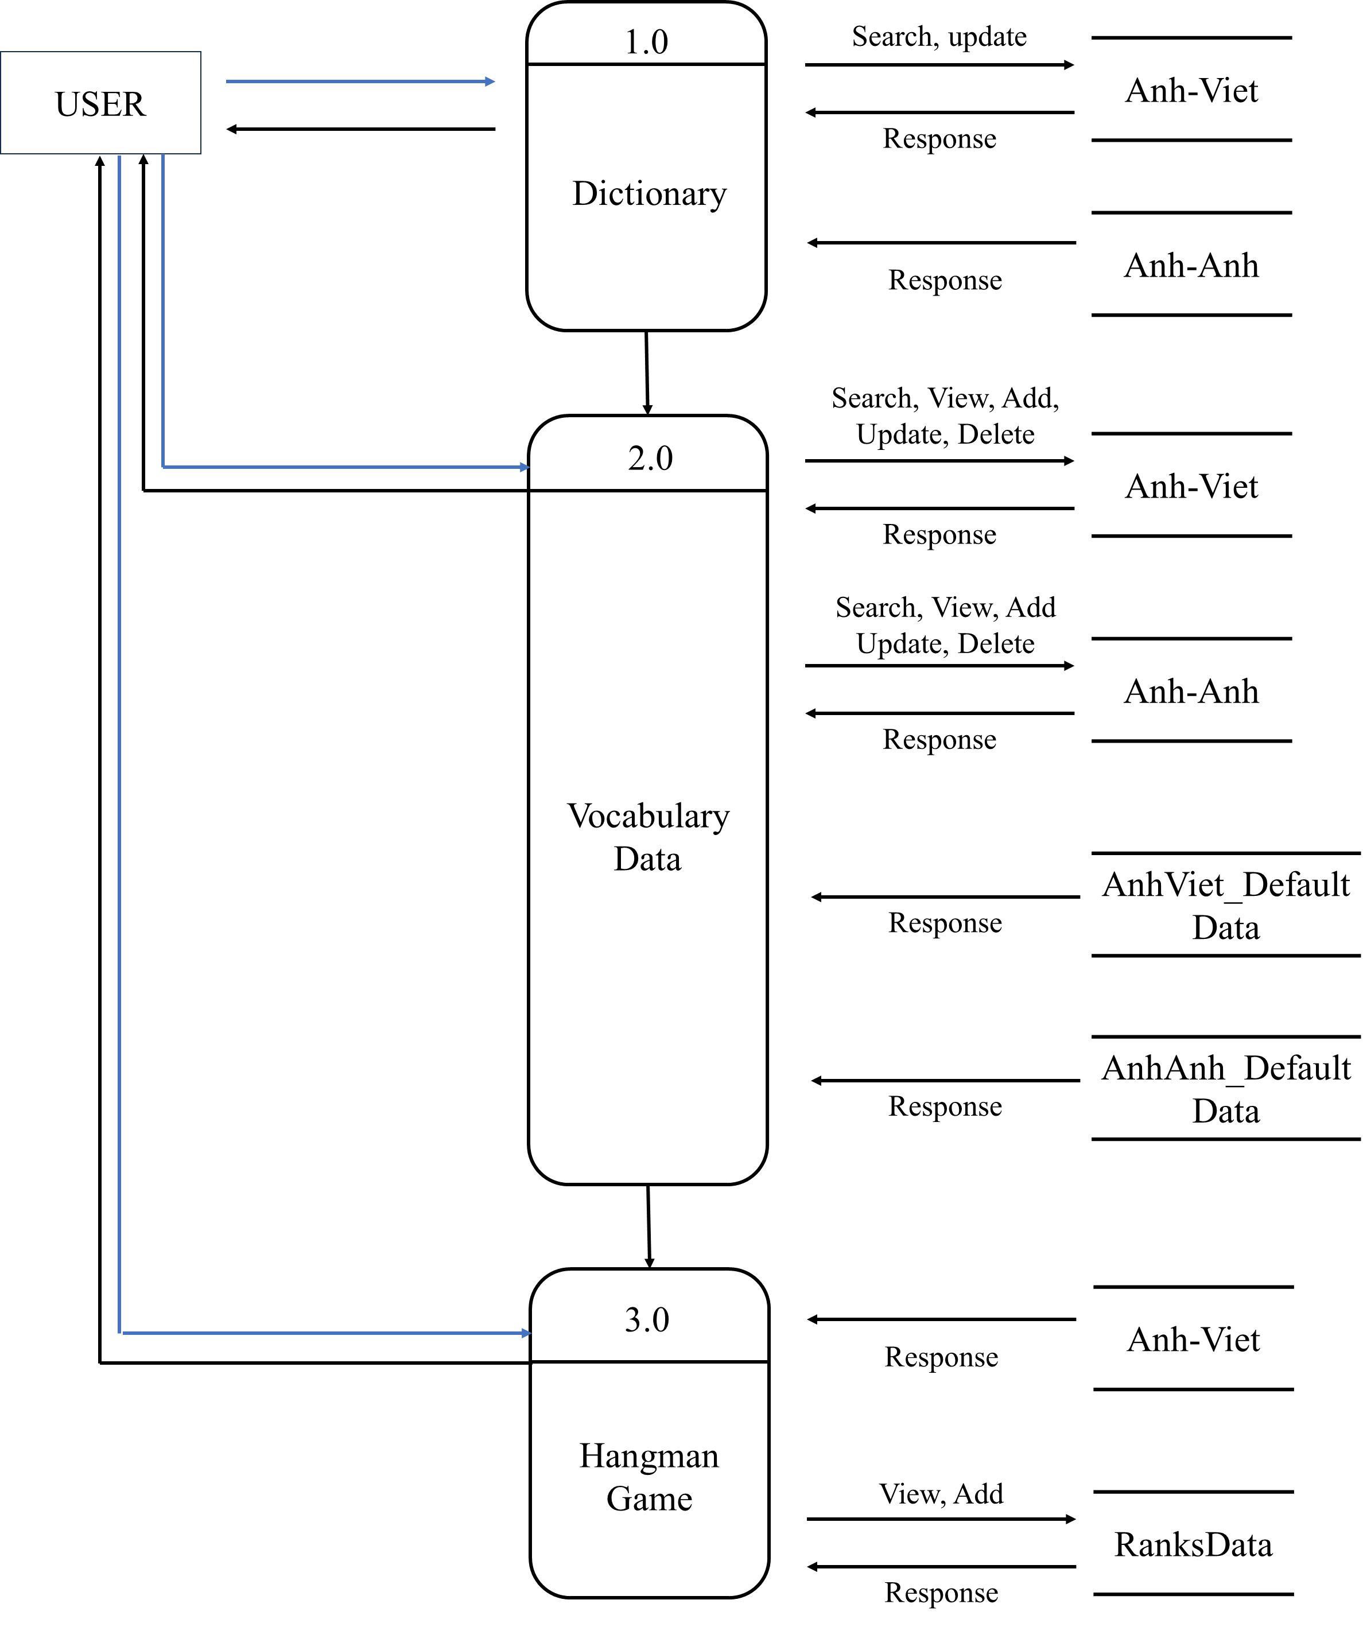

*LEVEL 2:*

*Dictionary:*

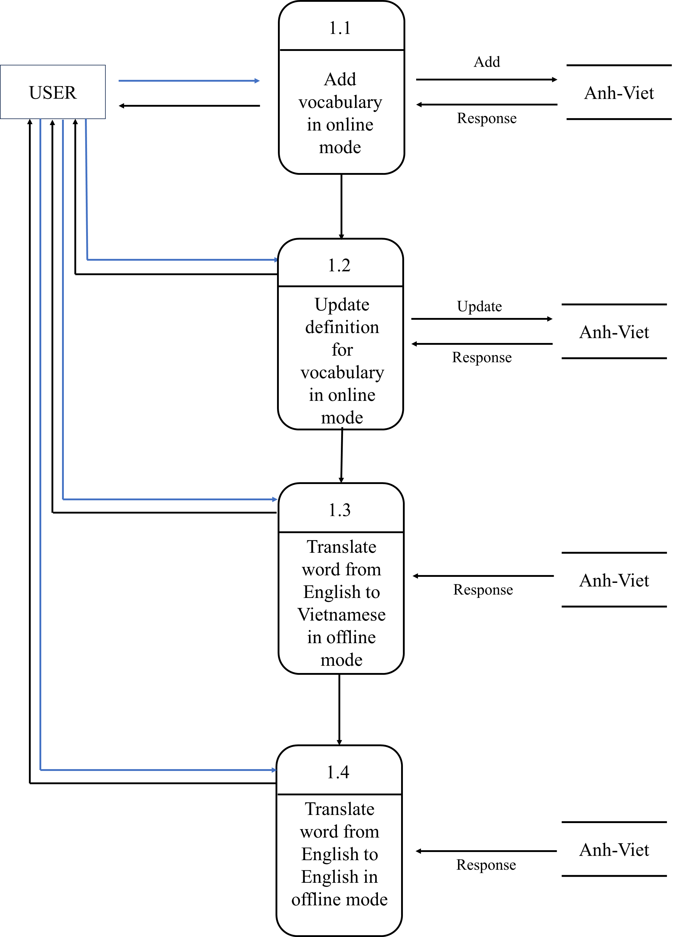

*Vocabulary data:*

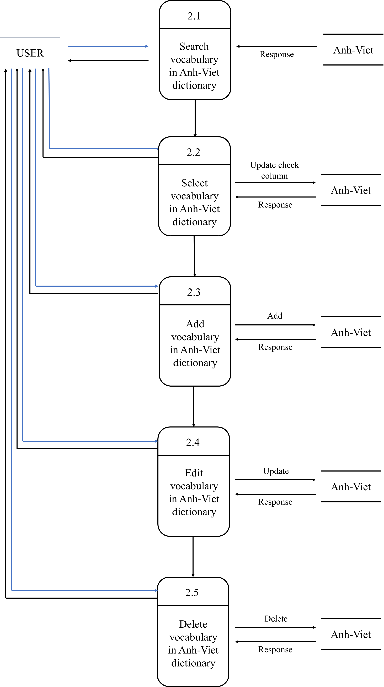

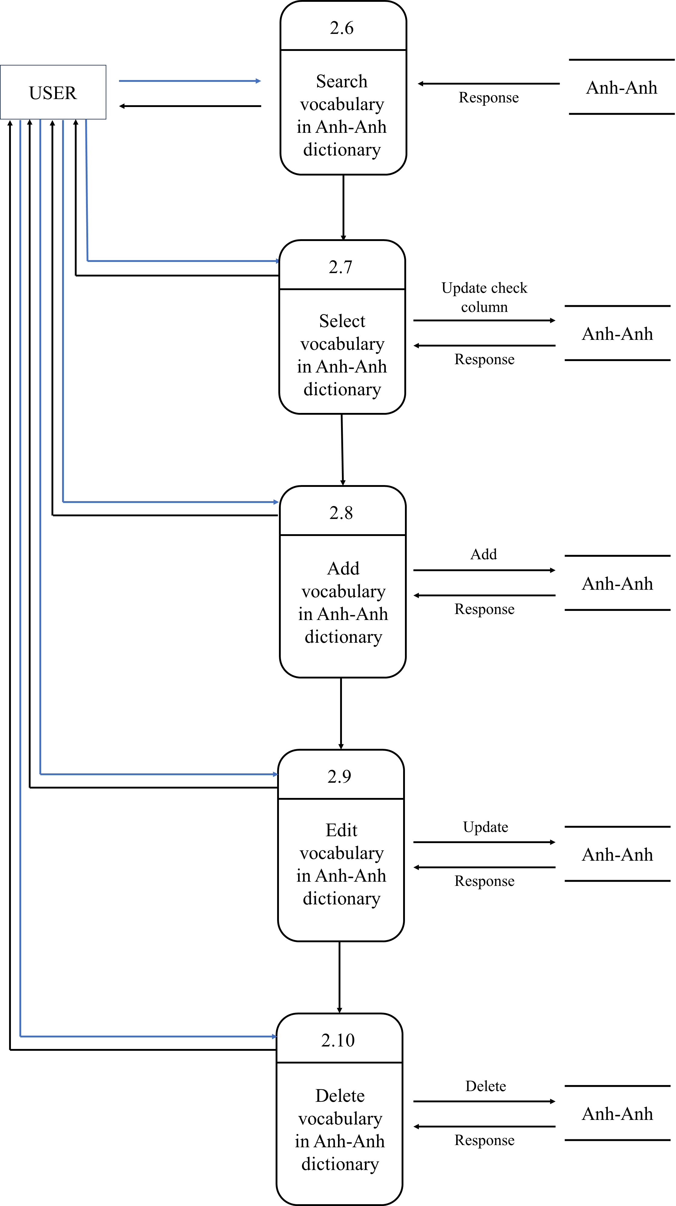

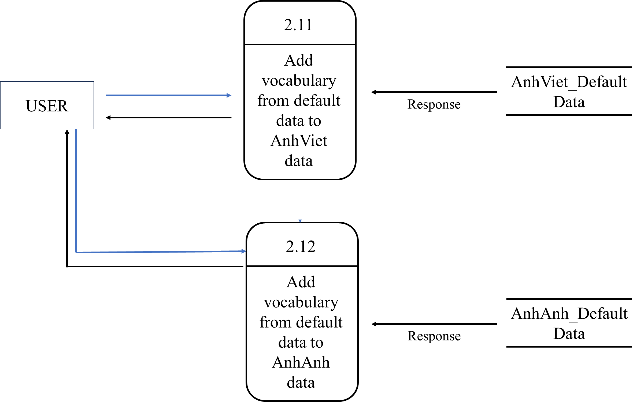

*Hangman game:*

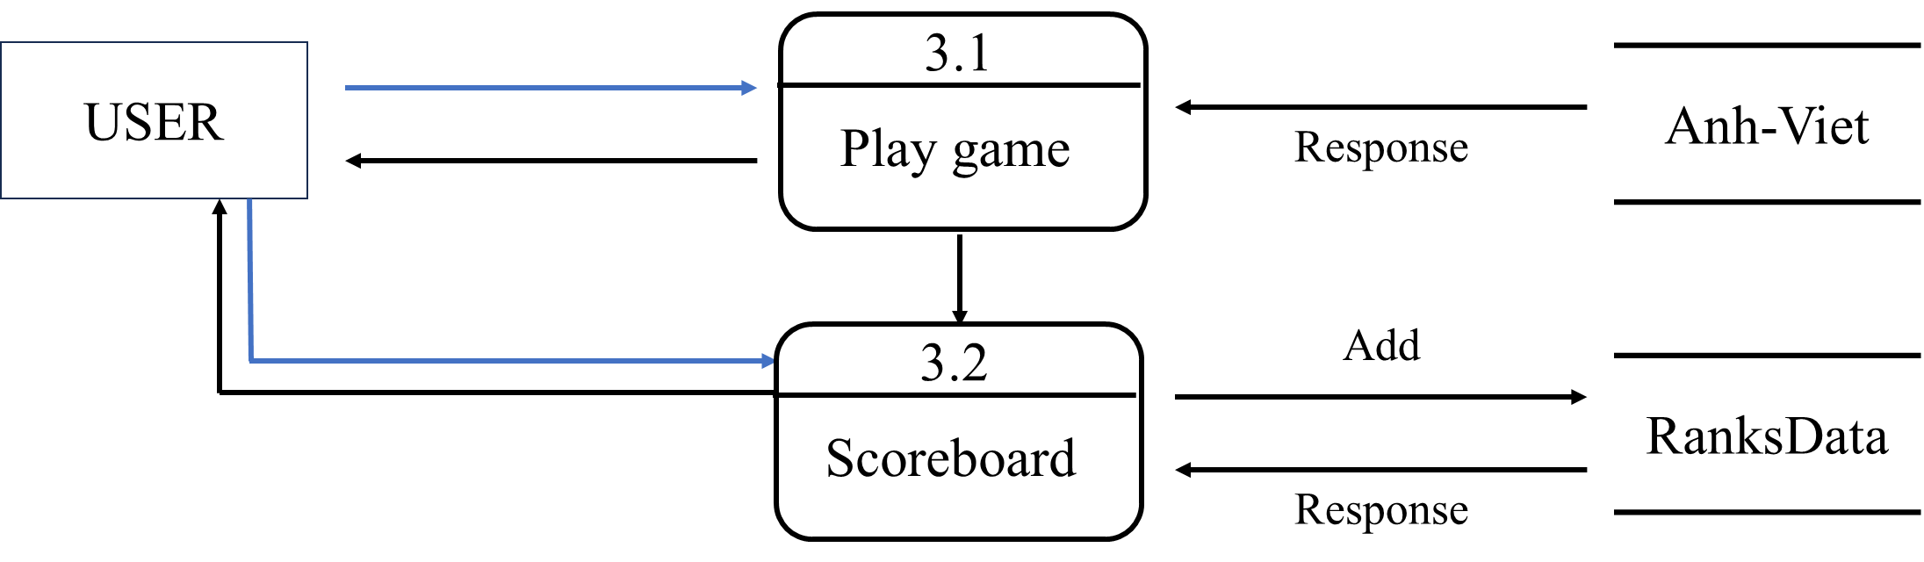

*LEVEL 3:*

*Dictionary:*

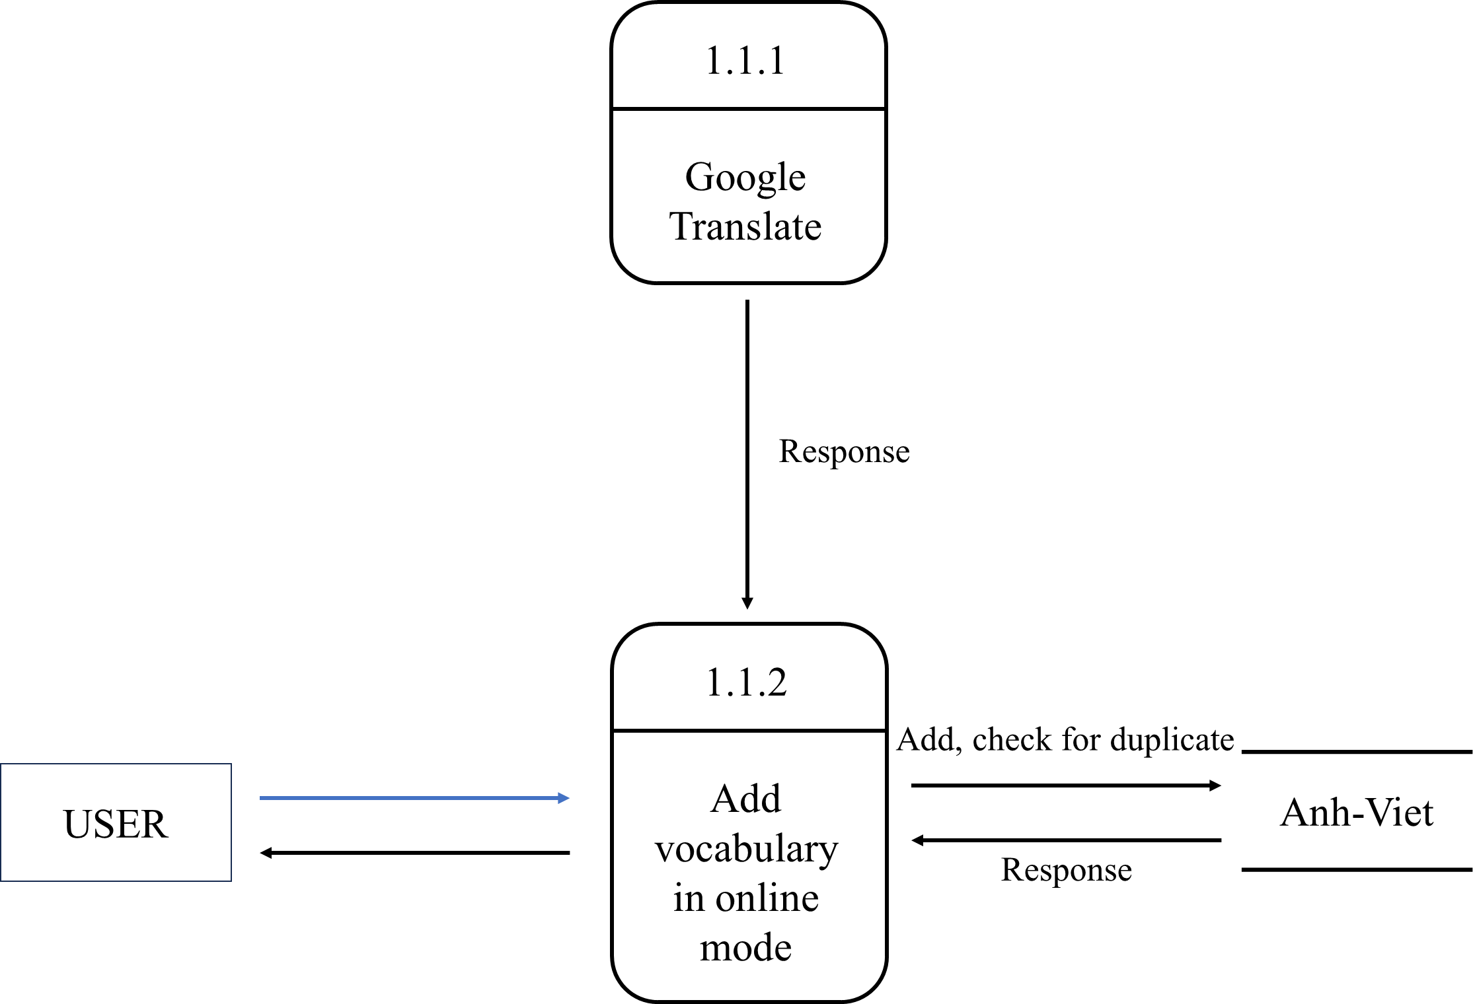

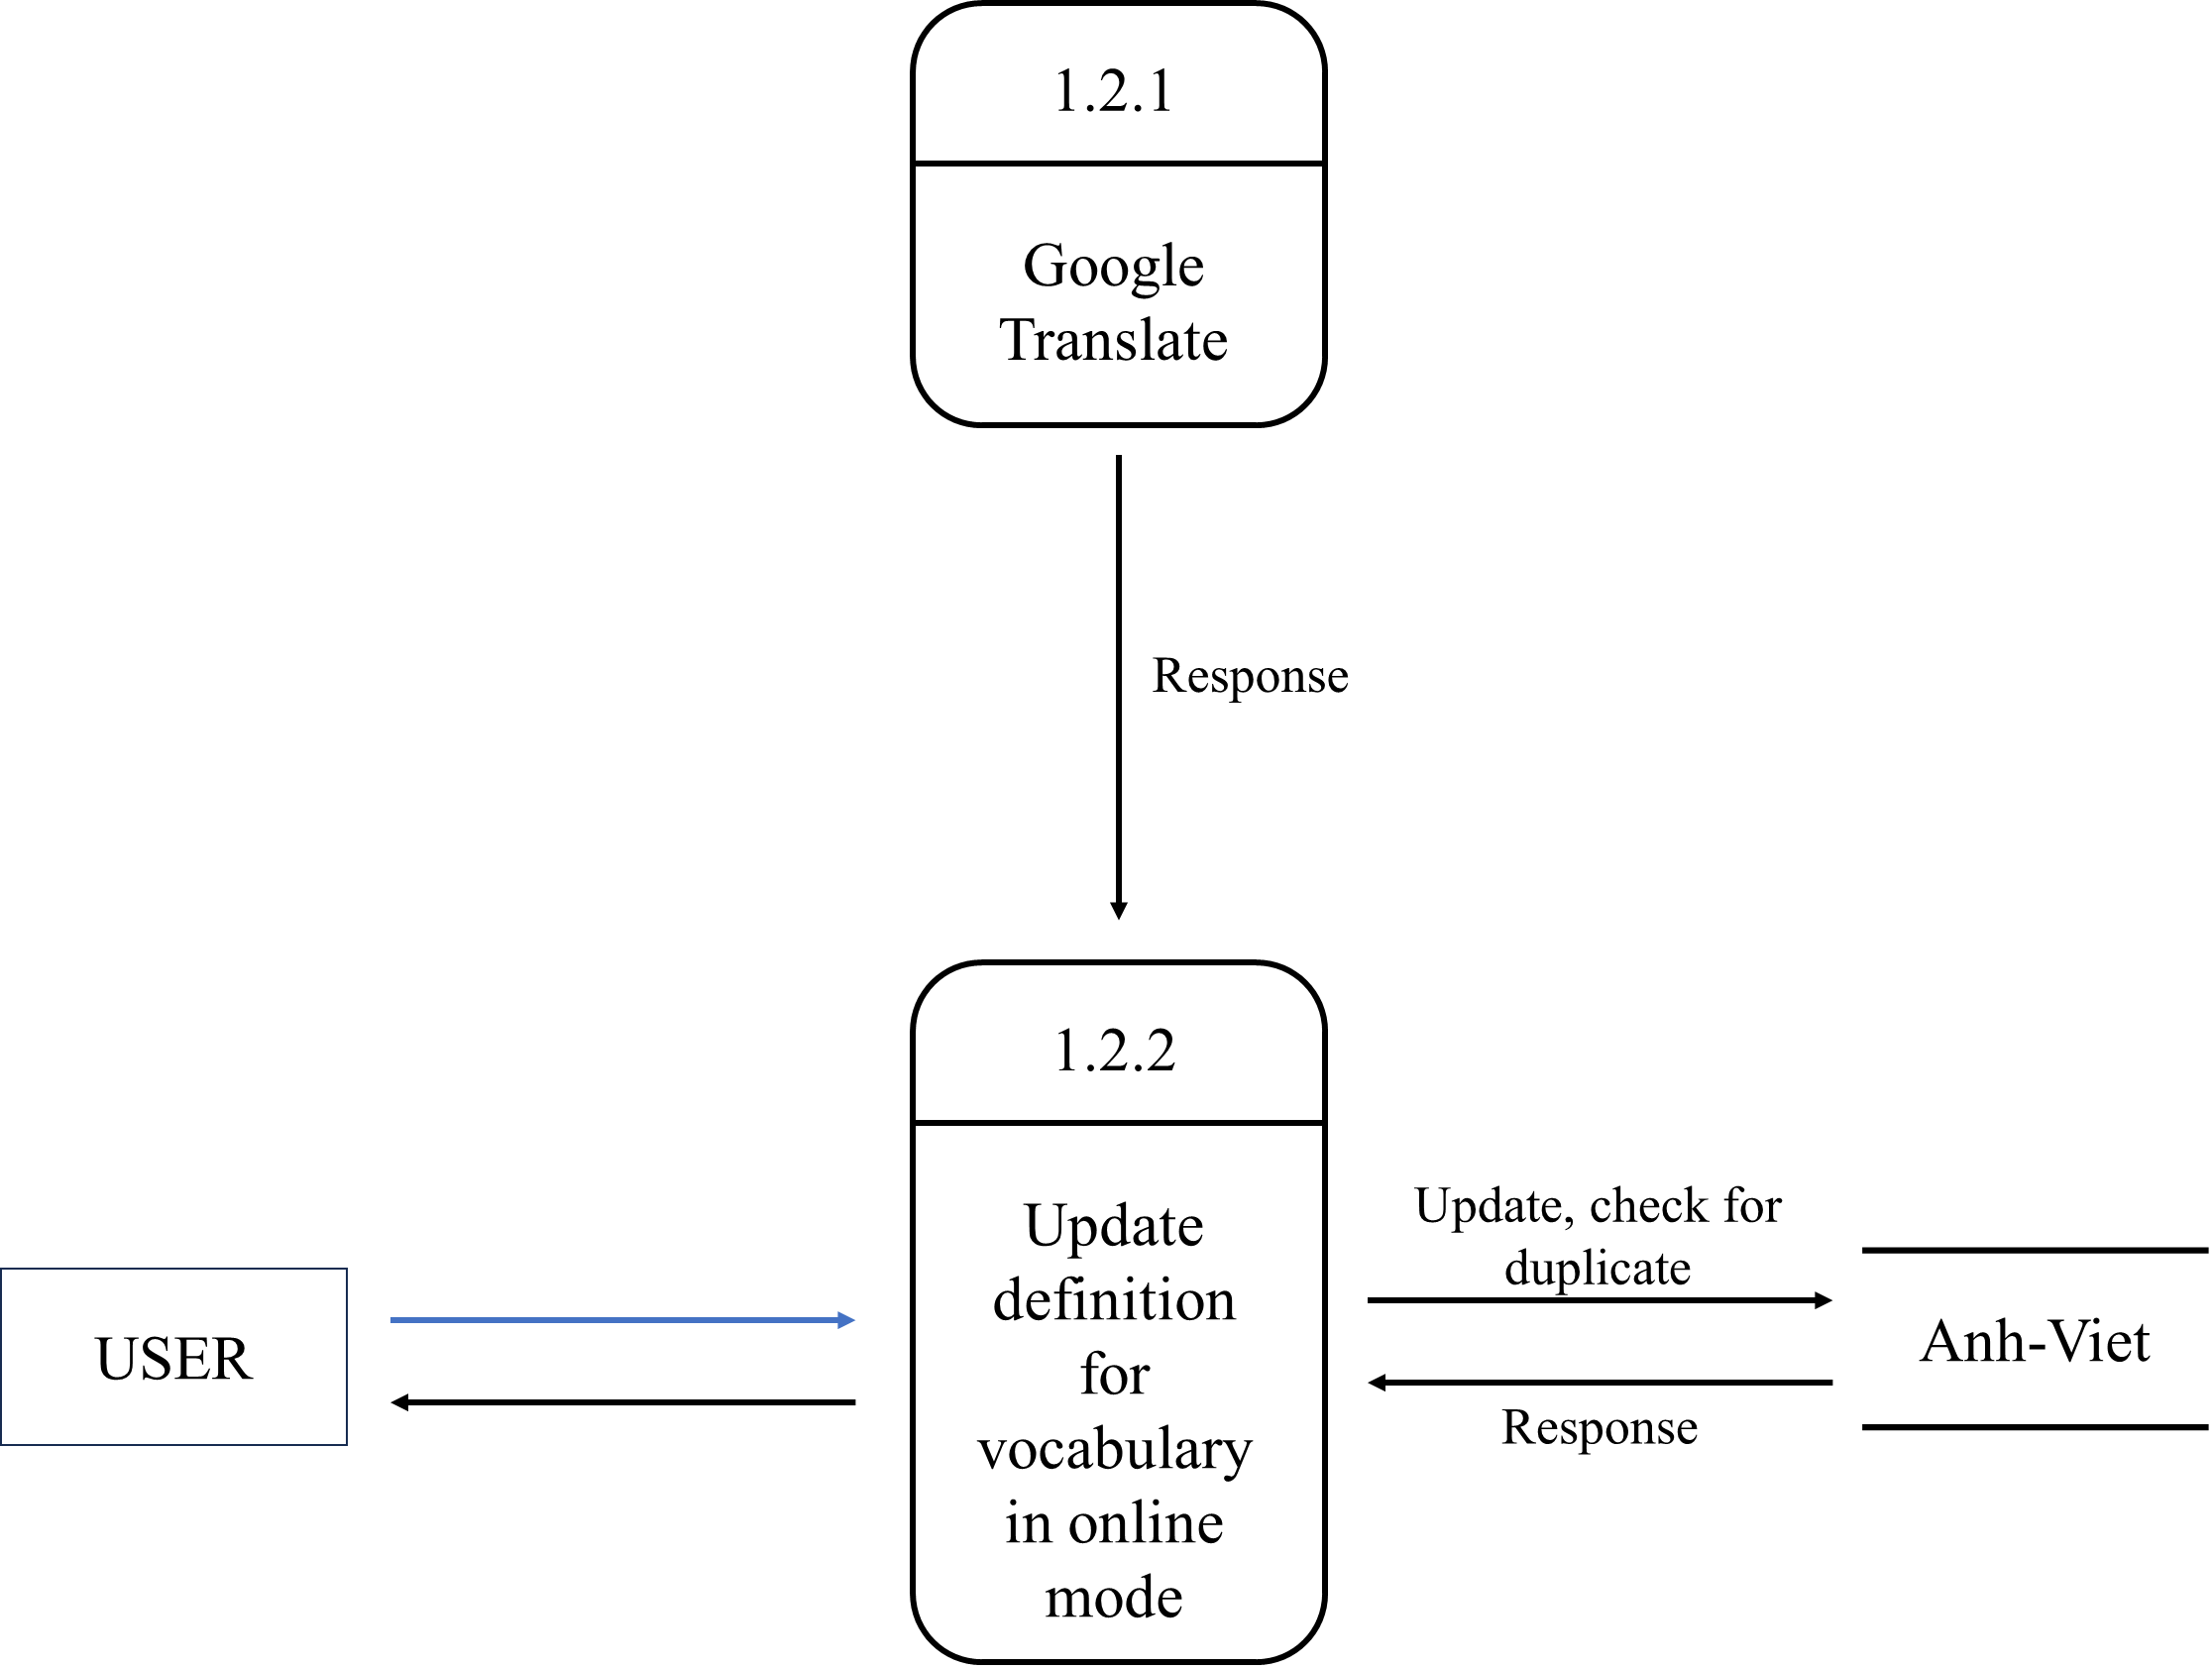

*Vocabulary data:*

*Add in Anh-Viet dictionary:*

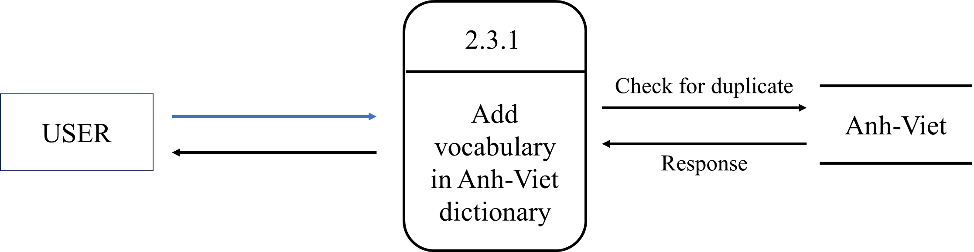

*Edit in Anh-Viet dictionary:*

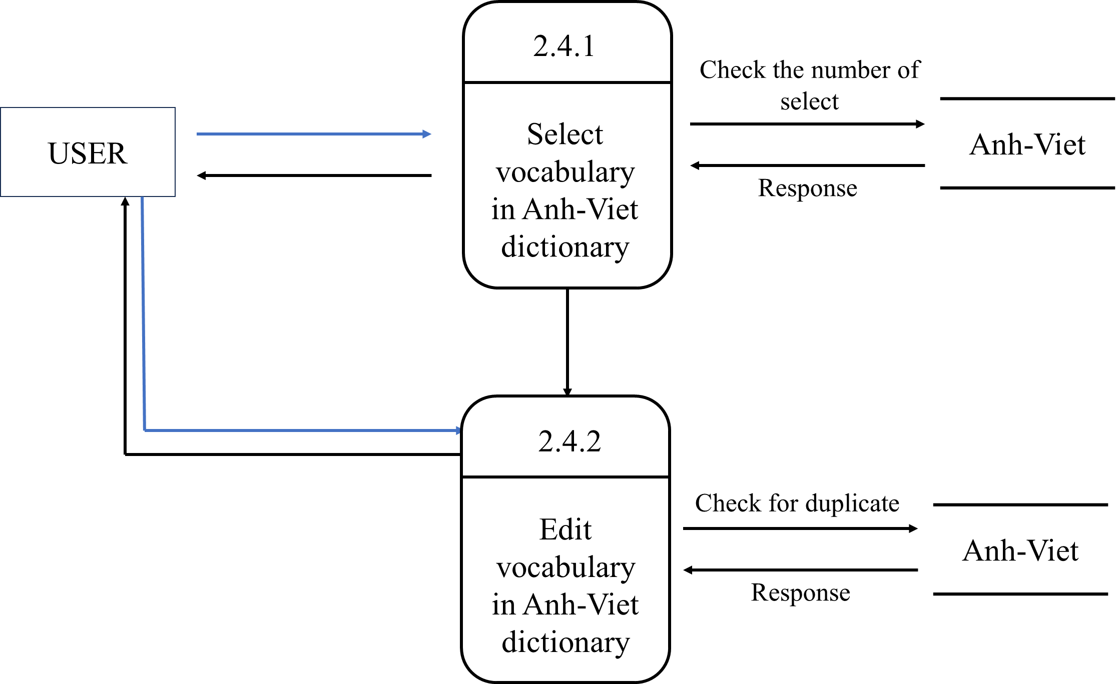

*Add vocabulary from default data to AnhViet data:*

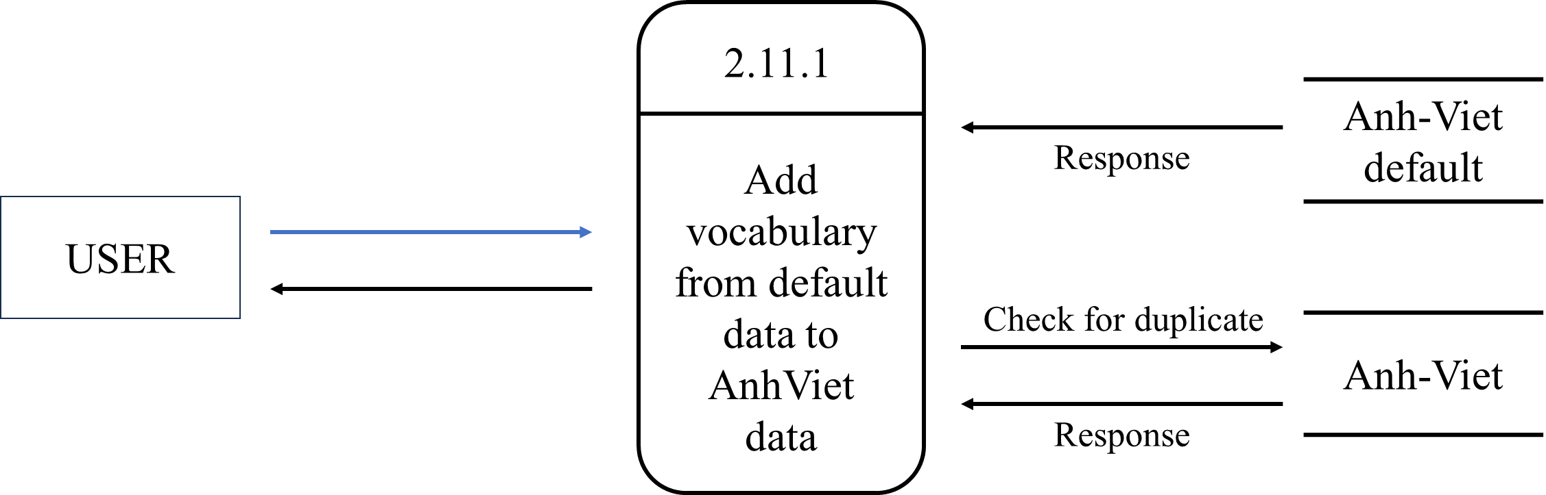

*Add in Anh-Anh dictionary:*

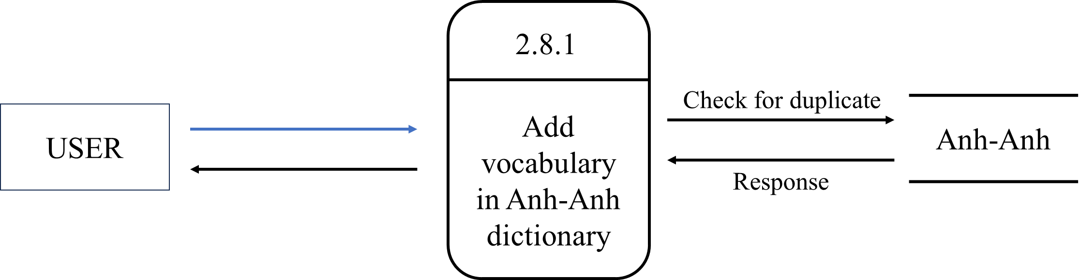

*Edit in Anh-Anh dictionary:*

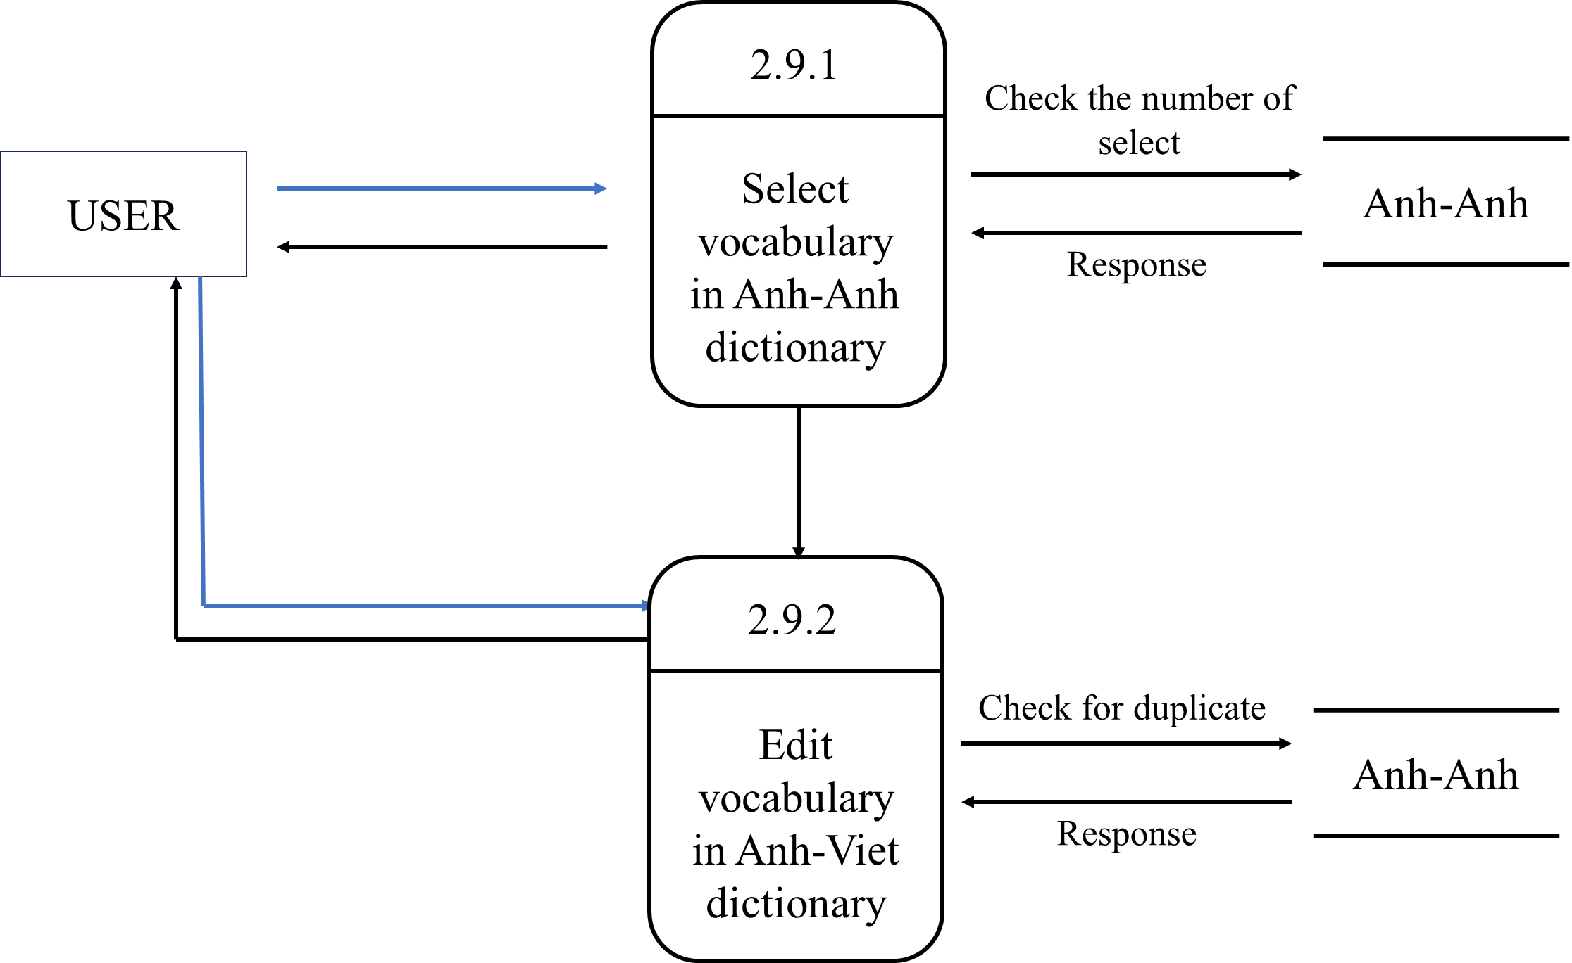

*Add vocabulary from default data to AnhViet data:*

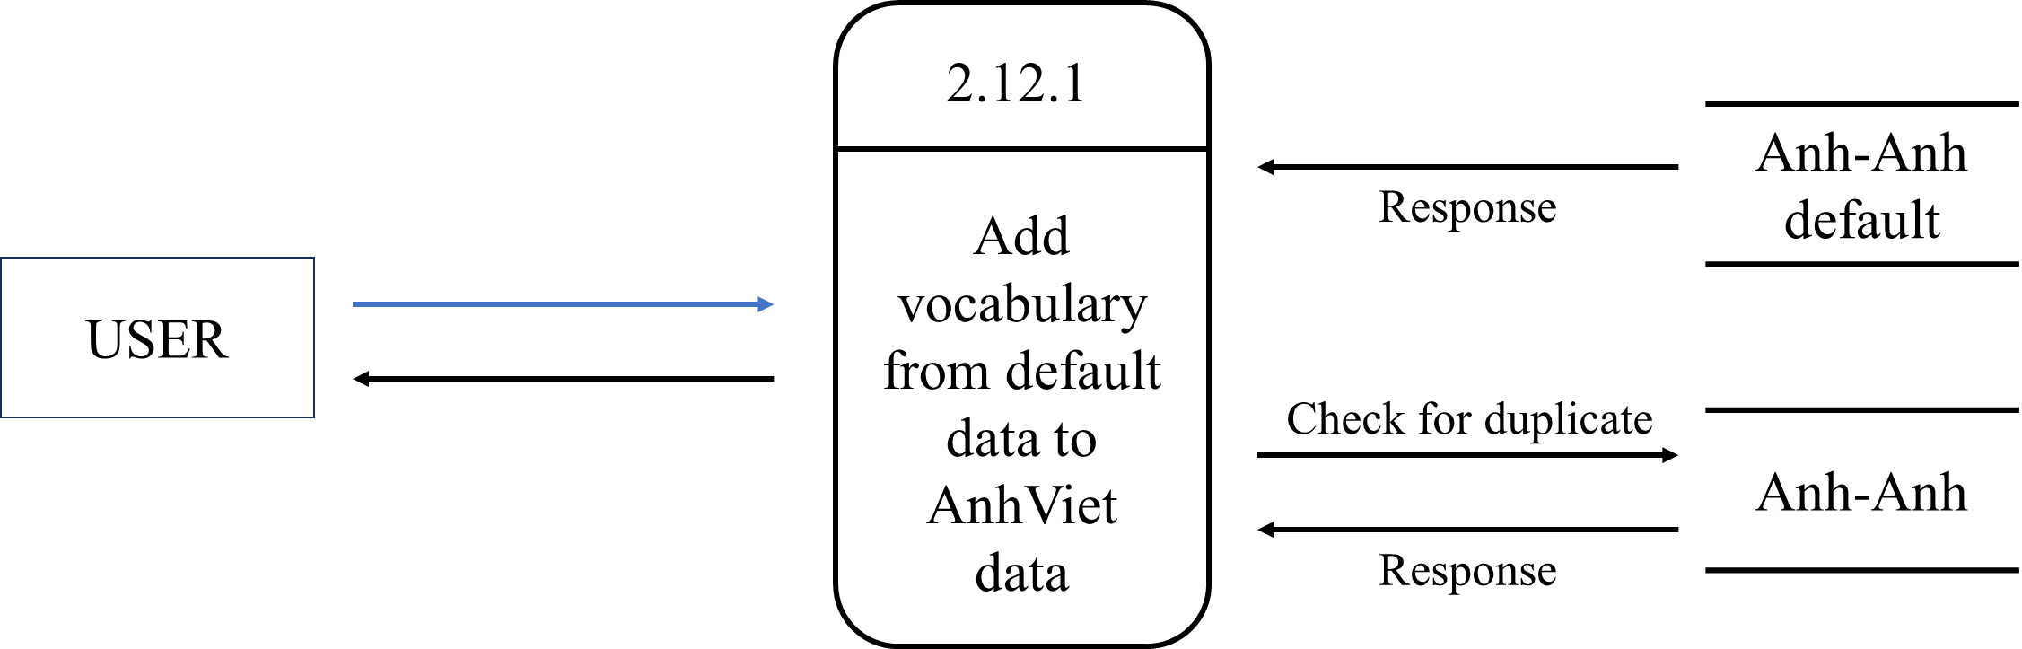

*Hangman game:*

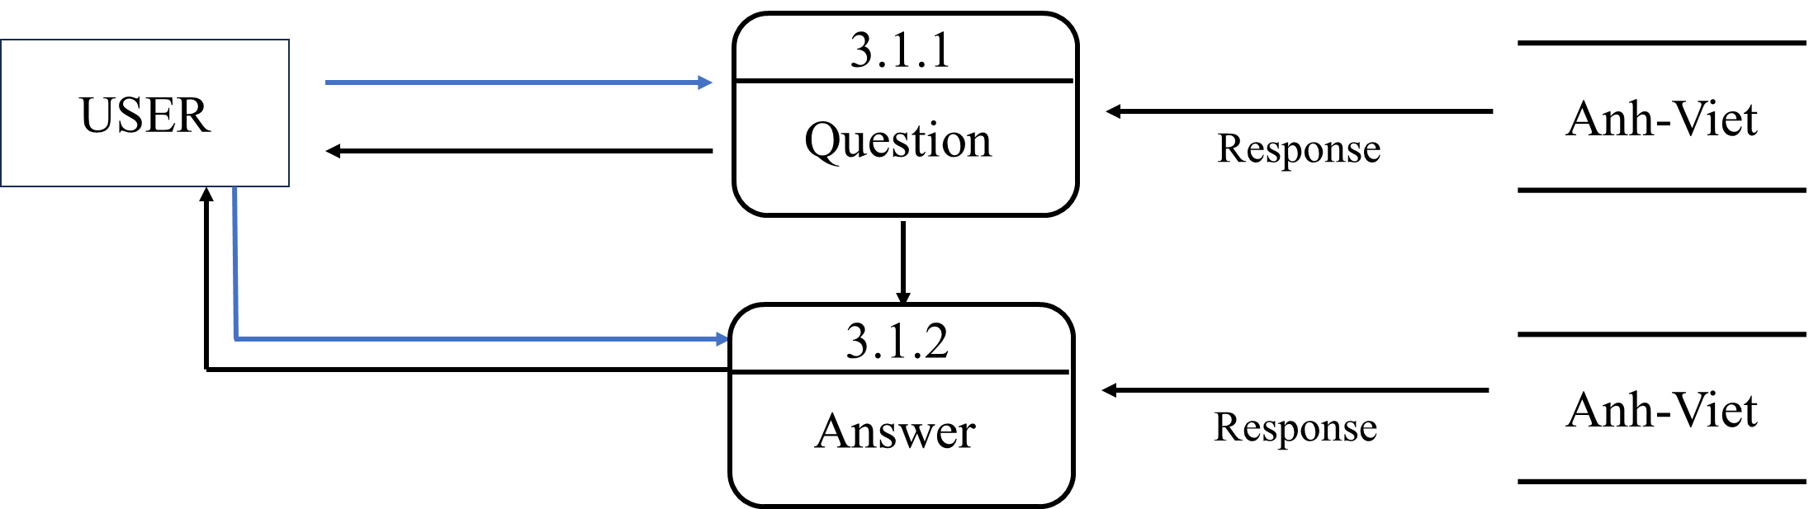

## **ENTITY PROPERTIES**

*AnhViet:*

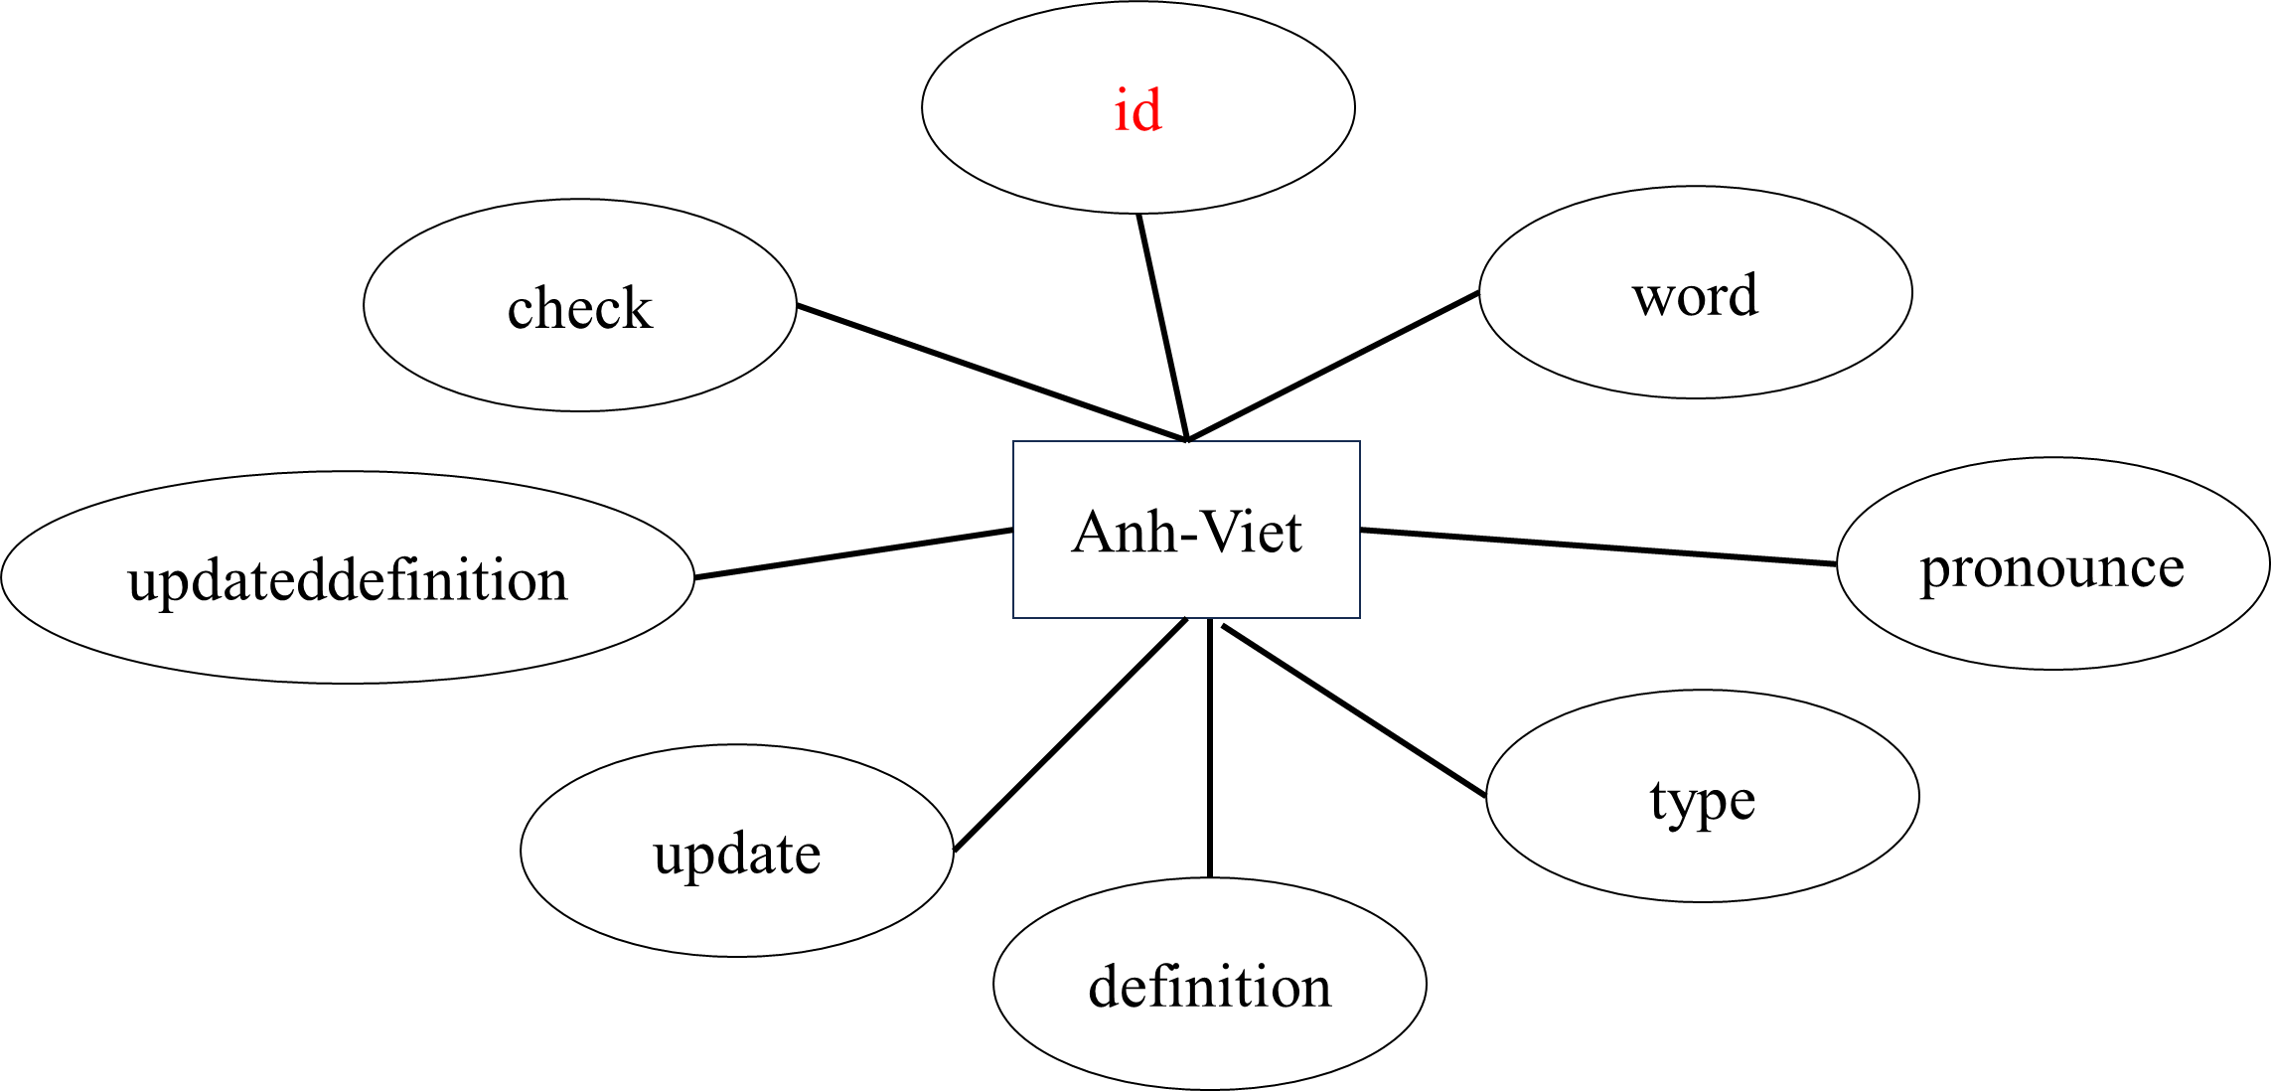

*AnhAnh:*

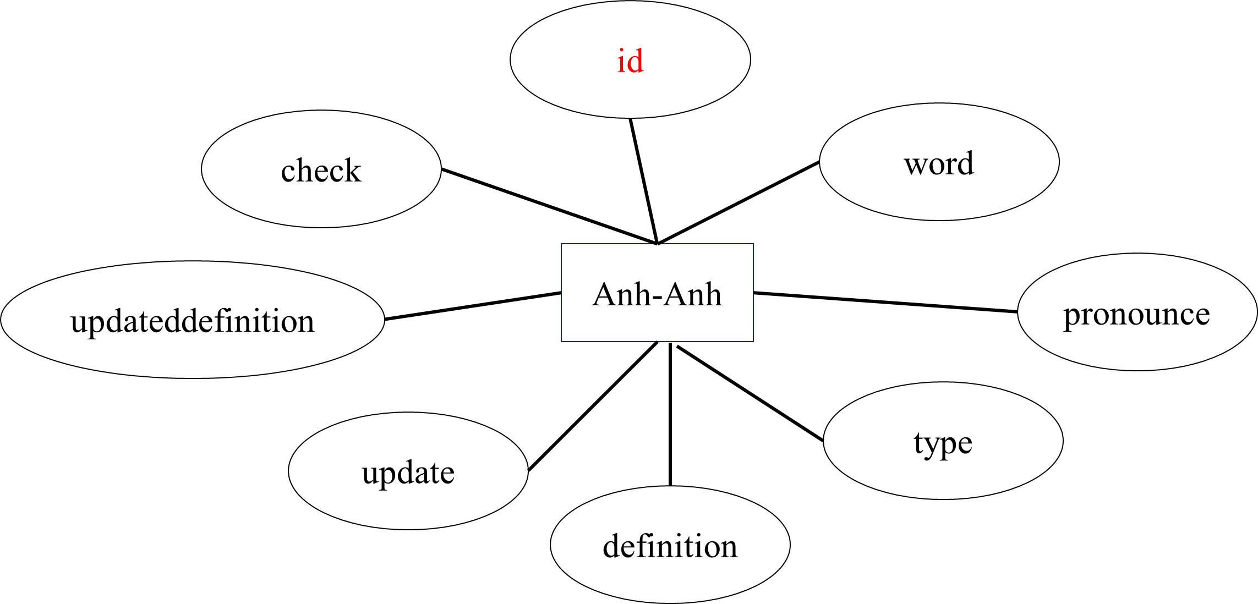

*AnhViet_DefaultData:*

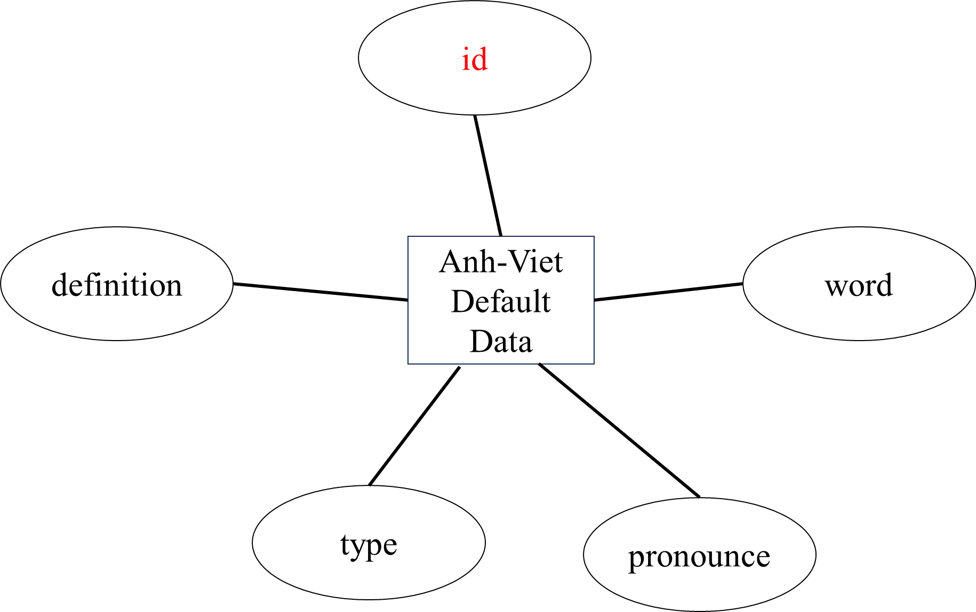

*AnhAnh_DefaultData:*

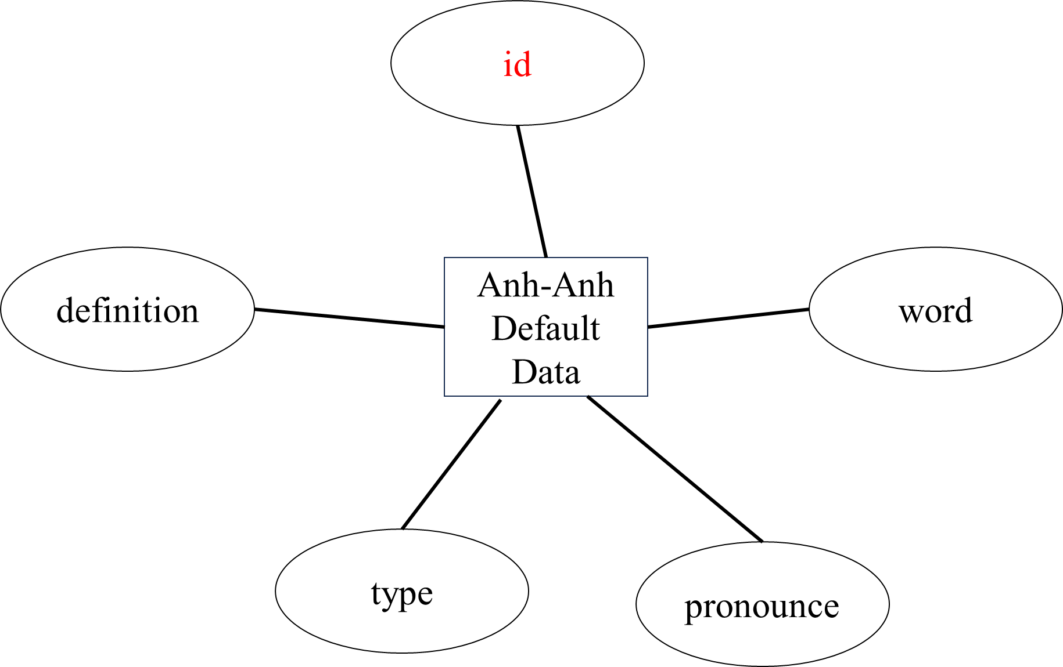

*RanksData:*

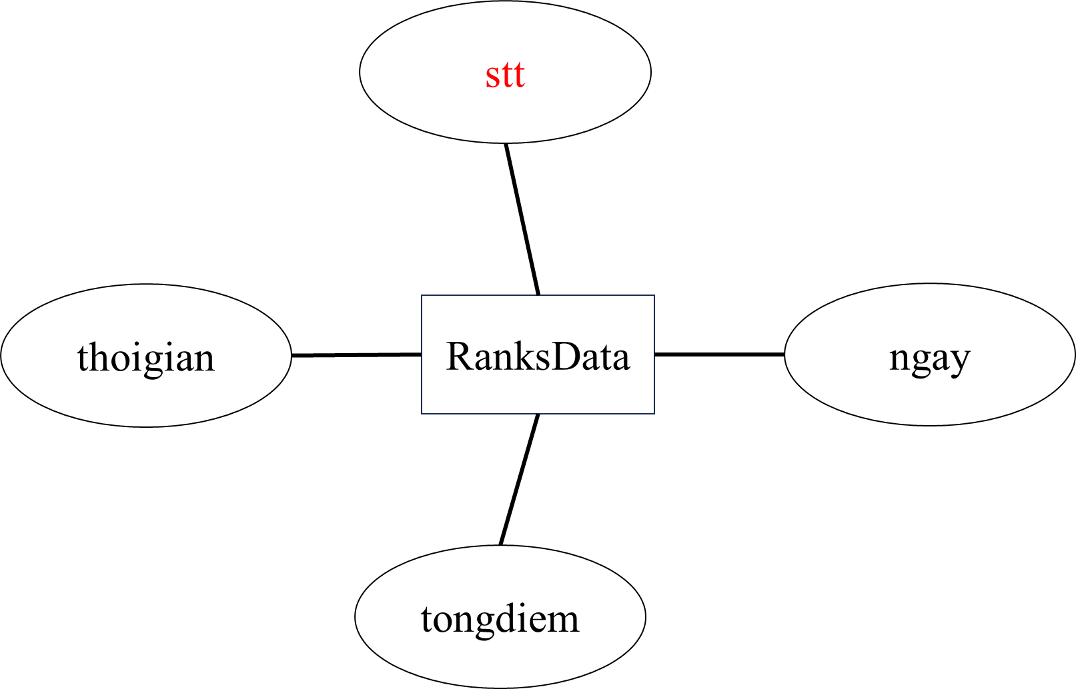

## **ENTITY RELATIONSHIP DIAGRAM (ERD)**

*LOGICAL ERD*

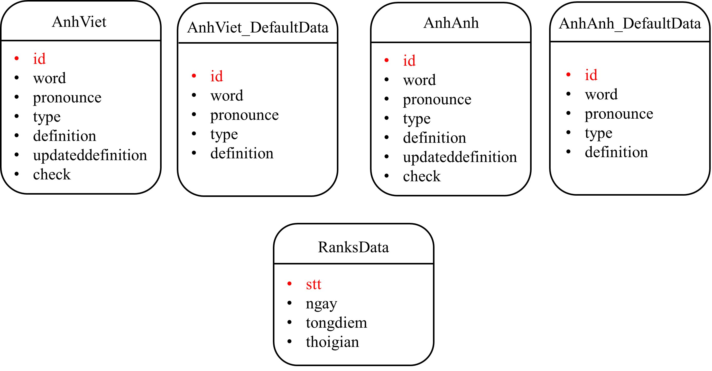

## **TABLE DESIGN**

*AnhViet table structure:*

|  |  |  |  |  |  |  |
| --- | --- | --- | --- | --- | --- | --- |
| **AnhViet Table** | | | | | | |
| **Column** | **Type** | **Auto Increment** | **Unique** | **Check** | **Null** | **Collate** |
| id (primary key) | integer | yes | yes | no | no | no |
| word | text | no | yes | no | no | no case sensitive |
| pronounce | text | no | no | no | yes | no |
| type | text | no | no | 'noun', 'verb', 'adjective', 'adverb' | no | no |
| definition | text | no | no | no | yes | no |
| update | text | no | no | no | yes | no |
| updateddefinition | text | no | no | no | yes | no |
| check | integer | no | no | 0, 1 | no | no |

*AnhViet_DefaultData table structure:*

|  |  |  |  |  |  |  |
| --- | --- | --- | --- | --- | --- | --- |
| **AnhViet_DefaultData Table** | | | | | | |
| **Column** | **Type** | **Auto Increment** | **Unique** | **Check** | **Null** | **Collate** |
| id (primary key) | integer | yes | yes | no | no | no |
| word | text | no | yes | no | no | no case sensitive |
| pronounce | text | no | no | no | yes | no |
| type | text | no | no | 'noun', 'verb', 'adjective', 'adverb' | no | no |
| definition | text | no | no | no | yes | no |

*AnhAnh table structure:*

|  |  |  |  |  |  |  |
| --- | --- | --- | --- | --- | --- | --- |
| **AnhAnh Table** | | | | | | |
| **Column** | **Type** | **Auto Increment** | **Unique** | **Check** | **Null** | **Collate** |
| id (primary key) | integer | yes | yes | no | no | no |
| word | text | no | yes | no | no | no case sensitive |
| pronounce | text | no | no | no | yes | no |
| type | text | no | no | 'noun', 'verb', 'adjective', 'adverb' | no | no |
| definition | text | no | no | no | yes | no |
| update | text | no | no | no | yes | no |
| updateddefinition | text | no | no | no | yes | no |
| check | integer | no | no | 0, 1 | no | no |

*AnhAnh_DefaultData table structure:*

|  |  |  |  |  |  |  |
| --- | --- | --- | --- | --- | --- | --- |
| **AnhAnh_DefaultData Table** | | | | | | |
| **Column** | **Type** | **Auto Increment** | **Unique** | **Check** | **Null** | **Collate** |
| id (primary key) | integer | yes | yes | no | no | no |
| word | text | no | yes | no | no | no case sensitive |
| pronounce | text | no | no | no | yes | no |
| type | text | no | no | 'noun', 'verb', 'adjective', 'adverb' | no | no |
| definition | text | no | no | no | yes | no |

*RanksData table structure:*

|  |  |  |  |  |  |  |
| --- | --- | --- | --- | --- | --- | --- |
| **RanksData Table** | | | | | | |
| **Column** | **Type** | **Auto Increment** | **Unique** | **Check** | **Null** | **Collate** |
| stt (primary key) | integer | yes | yes | no | no | no |
| ngay | text | no | no | no | no | no |
| tongdiem | integer | no | no | no | no | no |
| thoigian | text | no | no | no | no | no |

* **TASK SHEET REVIEW 2**

|  |  |  |  |  |  |  |  |  |
| --- | --- | --- | --- | --- | --- | --- | --- | --- |
| **Project: Translate This** | | **Project Name** | **Activity**  **Plan Prepared**  **By** | | **Date of Preparation of Activity Plan:** | | | |
| **Sr./No.** | **Task** | **Actual Start Date** | **Actual Days** | **Team member name** | **Status** |
| 1 | Architecture and design of the project | Translate This | Tuấn | | 12/Jan/2024 | 1 | Tuấn | Completed |
| 2 | Use case | 12/Jan/2024 | 2 | Nhung | Completed |
| 3 | Data flow diagram (DFD) | 12/Jan/2024 | 3 | Tuấn | Completed |
| 4 | Entity properties | 12/Jan/2024 | 1 | Nhung | Completed |
| 5 | Entity relationship diagram (ERD) | 13/Jan/2024 | 1 | Nhung | Completed |
| 6 | Table design | 13/Jan/2024 | 1 | Huy | Completed |
| 7 | Task Sheet 2 | 14/Jan/2024 | 1 | Tuấn | Completed |
| Date: 12 – JAN - 2024 | | | | | | | | |
| Signature of Instructor:  Ms. LÊ MỘNG THÚY | | | | Signature of Team Leader:  VŨ MINH TUẤN | | | | |

# **REVIEW 3**

## **APPLICATION MAP**

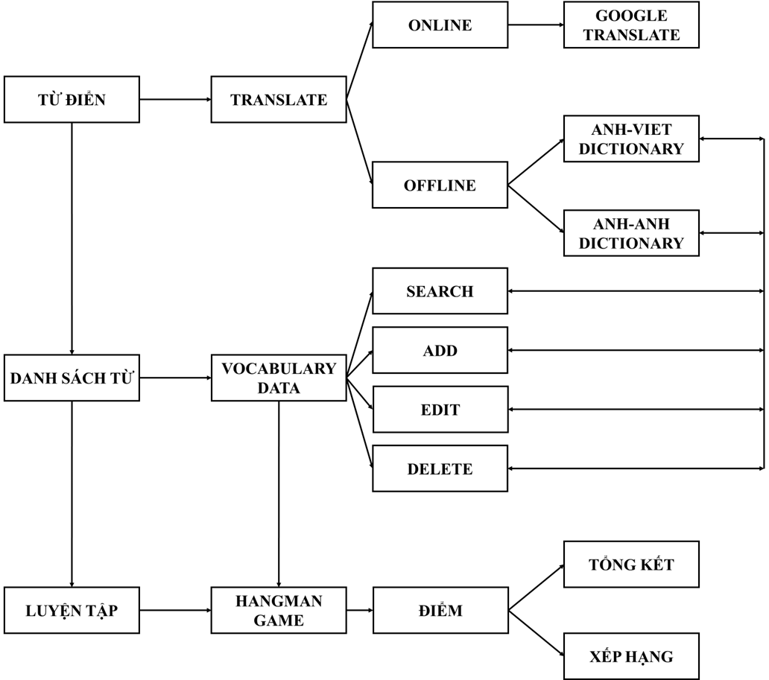

## **TRANSLATE THIS**

*Dictionary:*

1. *Display:*

* Interface for users to enter and display information about the word being translated such as pronunciation, word type, and definition.
* Online and offline mode switch.
* Translation language selection.

1. *Function:*

* Switching between online and offline mode allows looking up vocabulary from Google Translate or the system dictionary.
* Switching between two different languages: English and Vietnamese will result in the corresponding selection.
* Suggests vocabulary being input by the user if that exists in the database.
* Add vocabulary from Google Translate if that vocabulary does not exist in the database.
* Update vocabulary from Google Translate if that vocabulary exists in the database.

1. *Screen shot:*

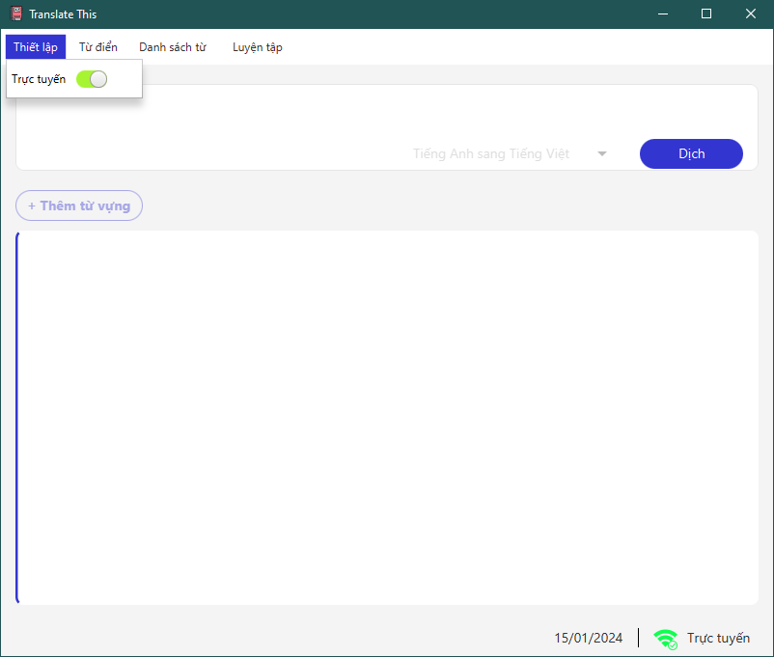

Figure 1: Setting mode

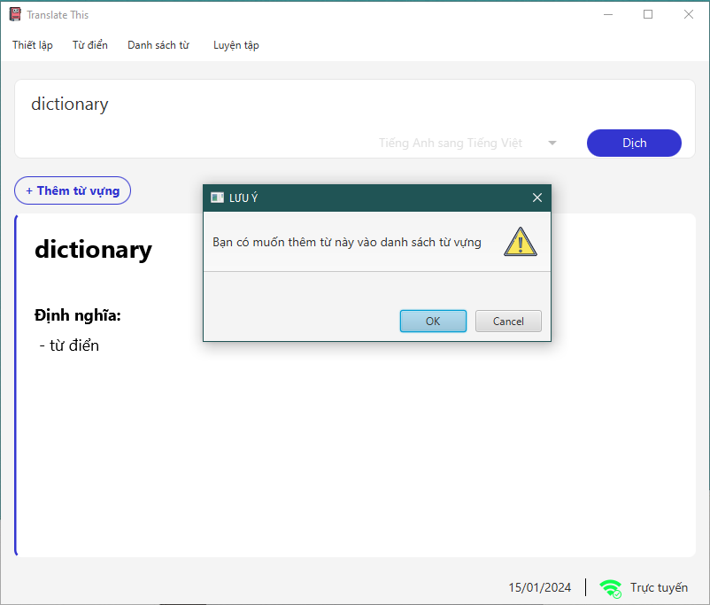

Figure 2: Add new vocabulary alert

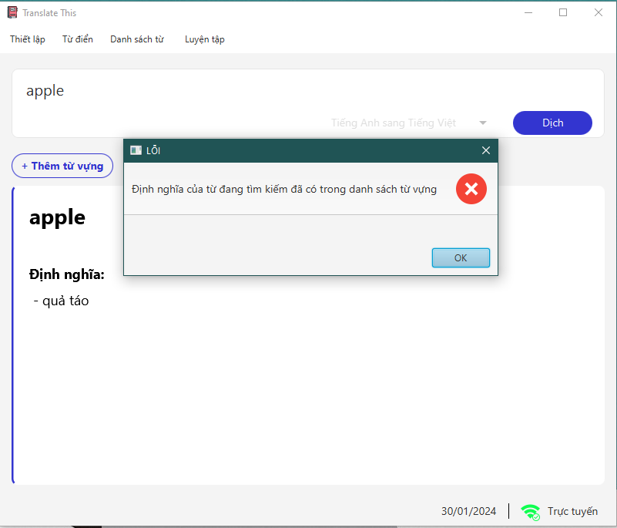

Figure 3: Check update the new definition for vocabulary

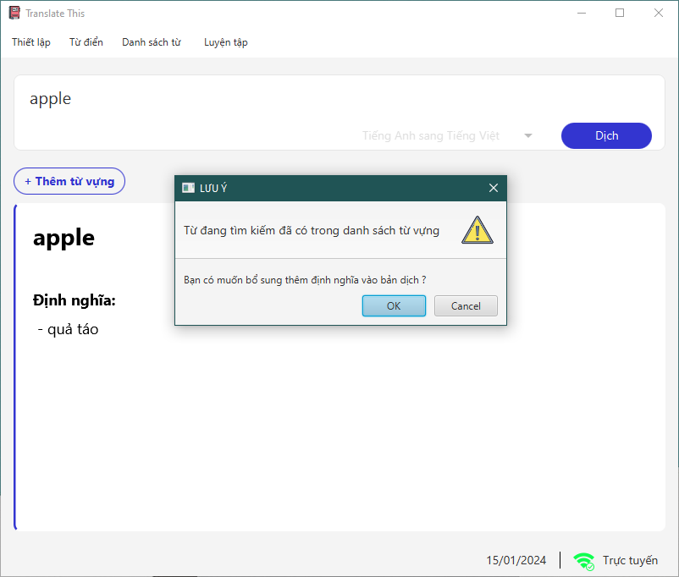

Figure 4: Update the new definition for vocabulary alert

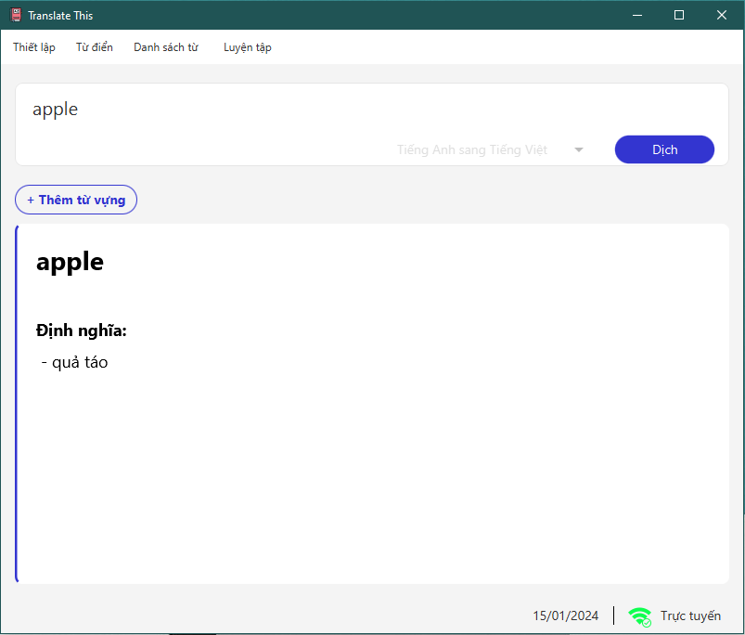

Figure 5: Google translate function in online mode

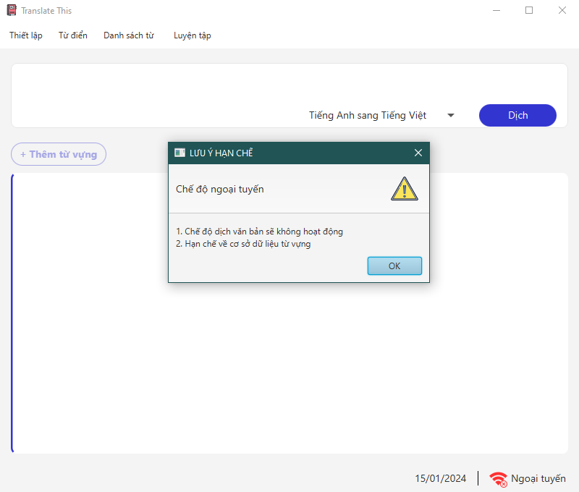

Figure 6: Offline mode alert

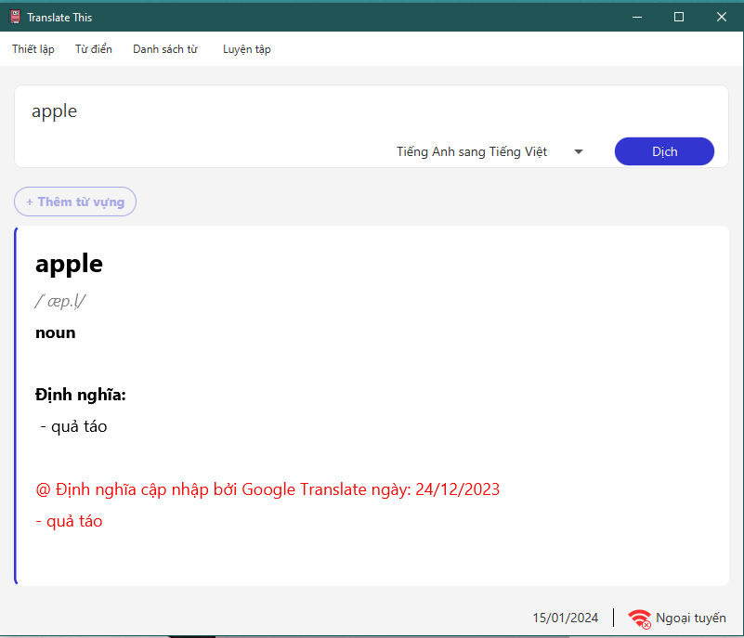

Figure 7: Anh-Viet dictionary in offline mode

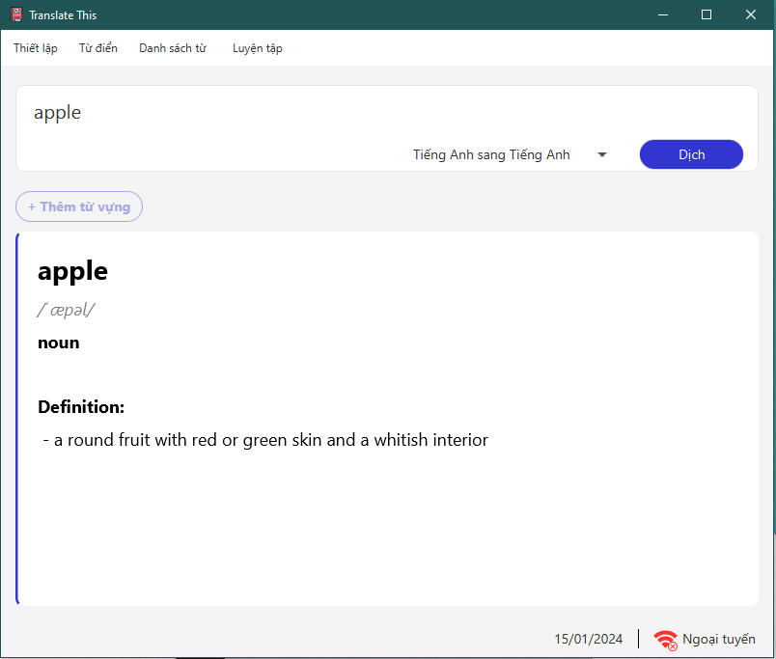

Figure 8: Anh-Anh dictionary in offline mode

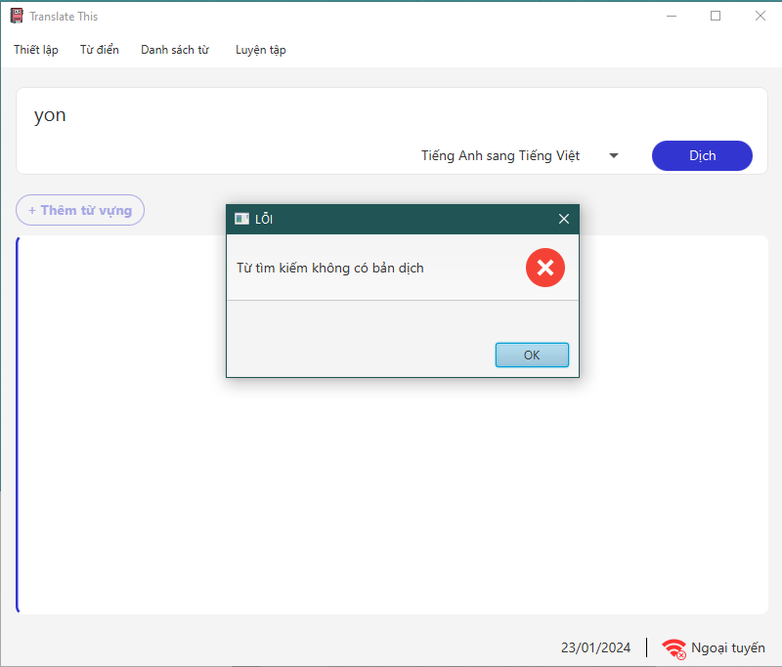

Figure 9: Vocabulary not found error

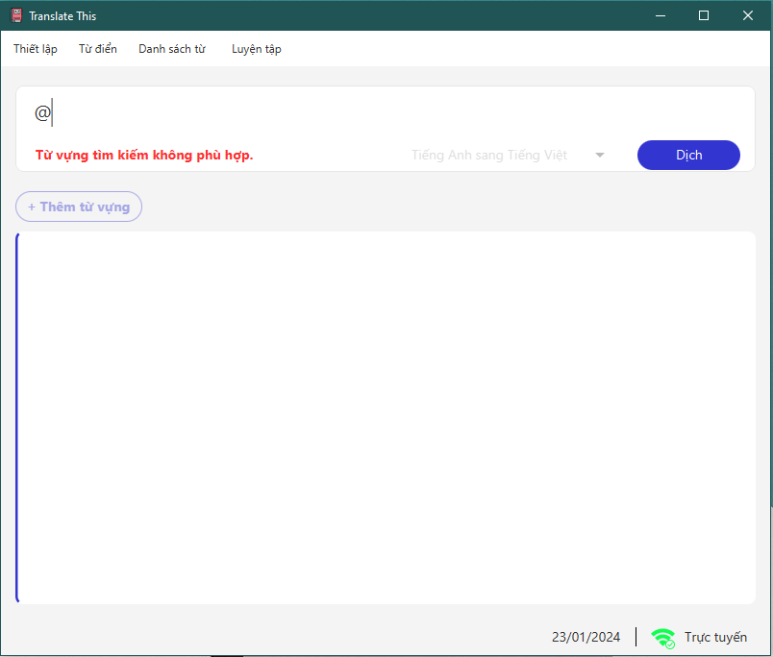

Figure 10: Check translate informations – 1

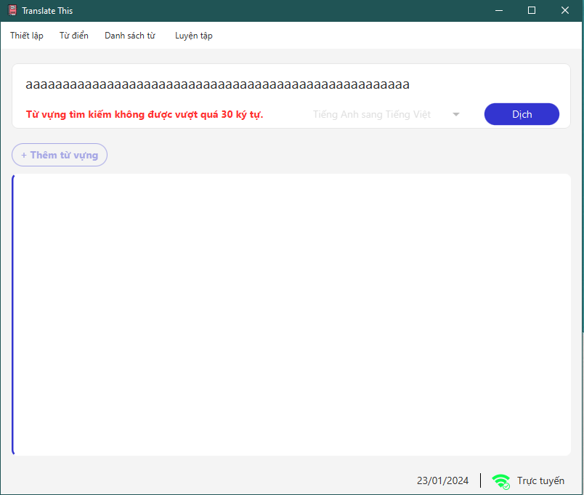

Figure 11: Check translate informations – 2

*Vocabulary data:*

1. *Display:*

* Interface interface allows users to view vocabulary data in the system and perform operations such as adding, deleting, and editing.

1. *Function:*

* Displays vocabulary in the list.
* Filtering vocabulary in the list according to criteria such as name, type, and dictionary.
* Selects vocabulary to perform operations.
* Adds vocabulary in user database.
* Updates vocabulary in user database.
* Deletes vocabulary in user database.
* Adds vocabulary from system data to user data.

1. *Screen shot:*

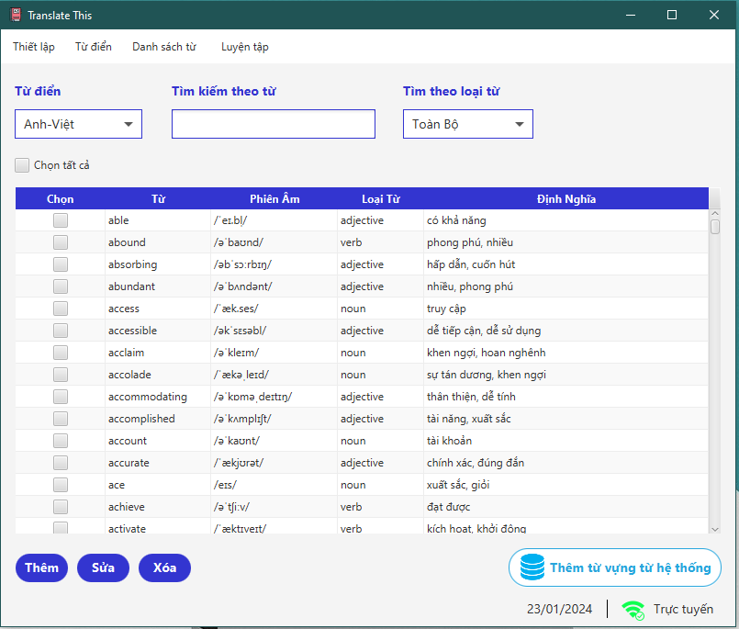

Figure 12: Vocabulary data – Anh-Việt dictionary

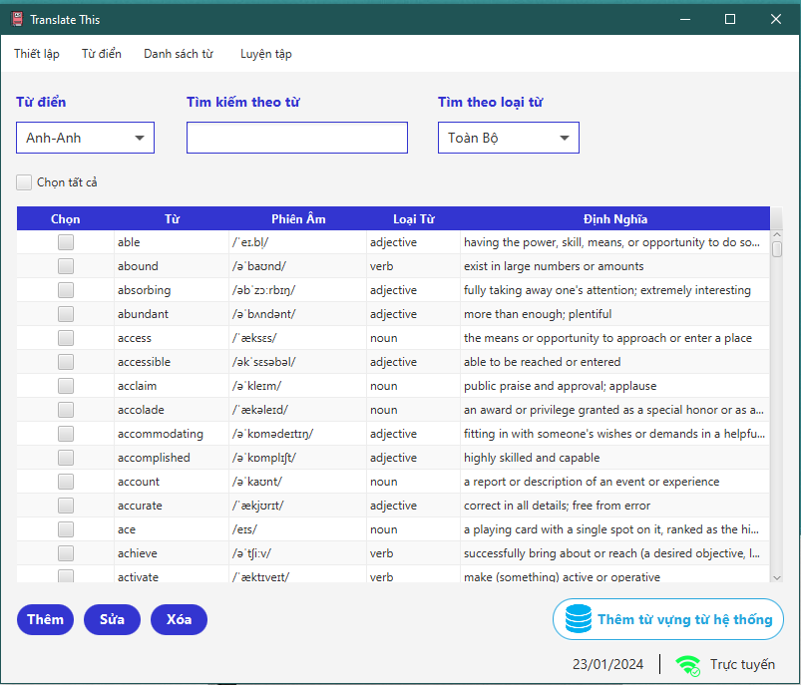

*Figure 13: Vocabulary data – Anh-Anh dictionary*

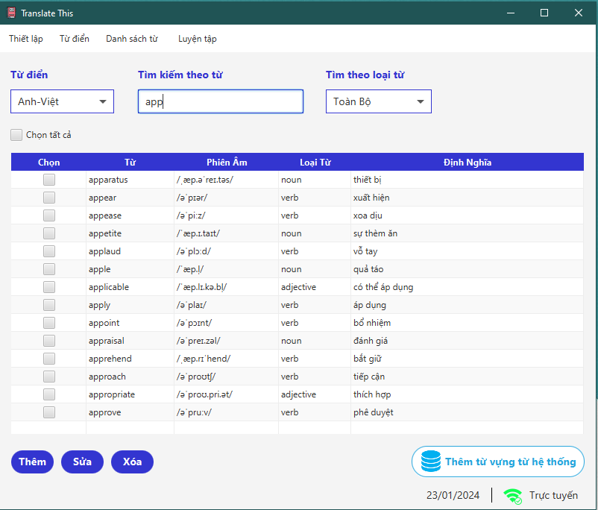

Figure 14: Search phrase

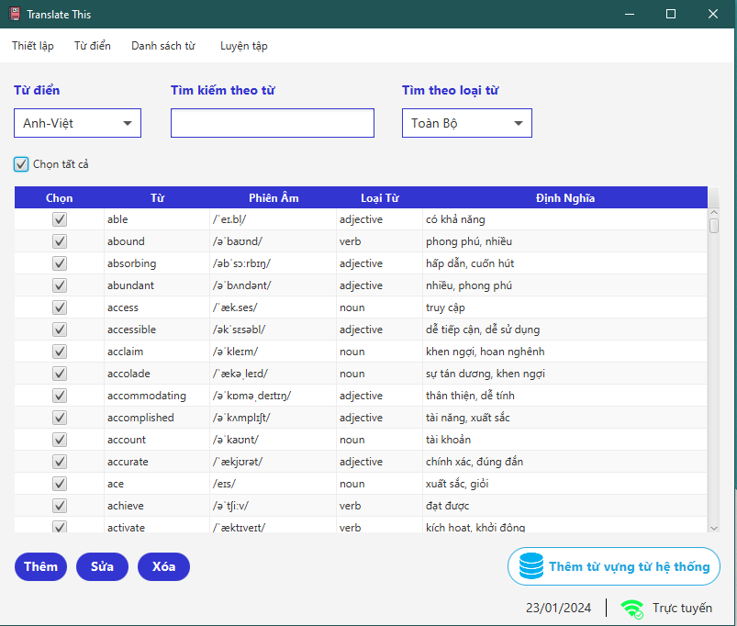

Figure 15: Select all

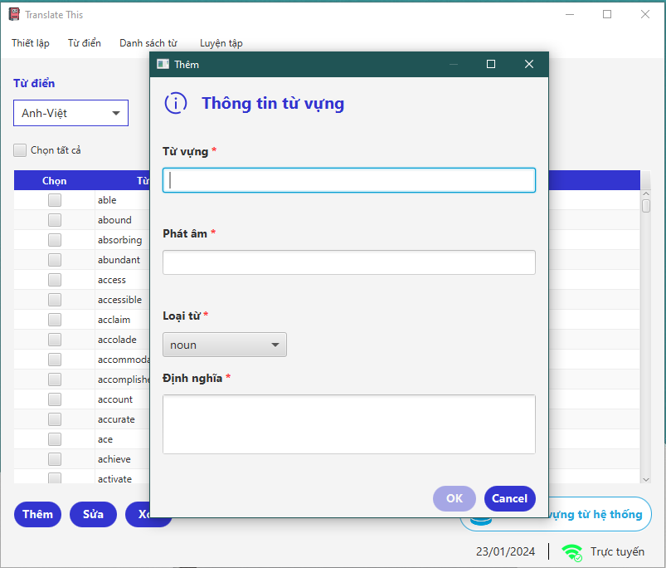

Figure 16: Add new vocabulary window

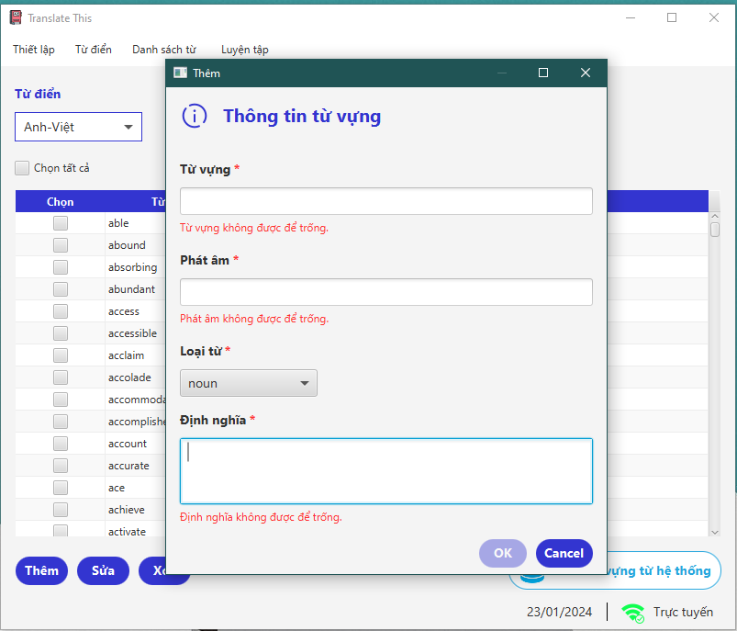

Figure 17: Check insert informations - 1

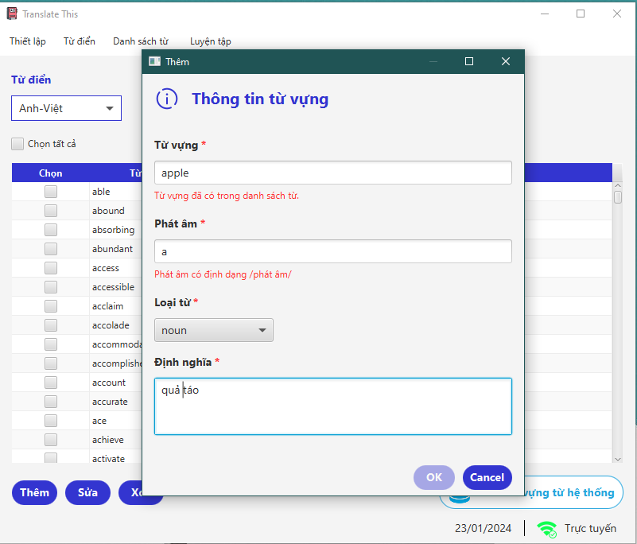

Figure 18: Check insert informations – 2

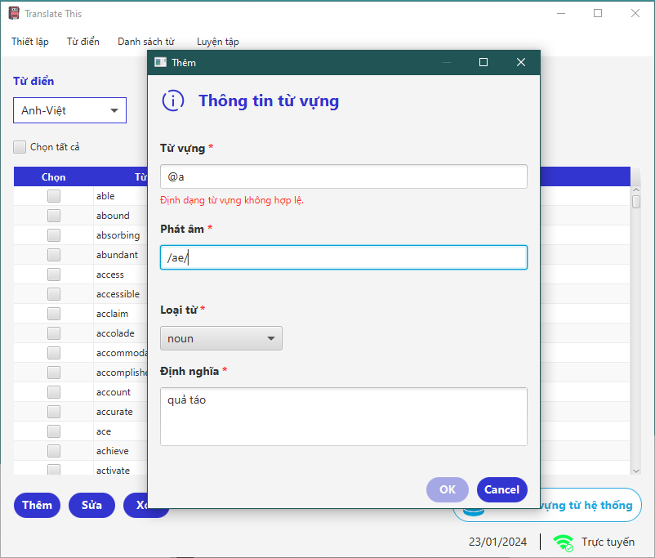

Figure 19: Check insert informations – 3

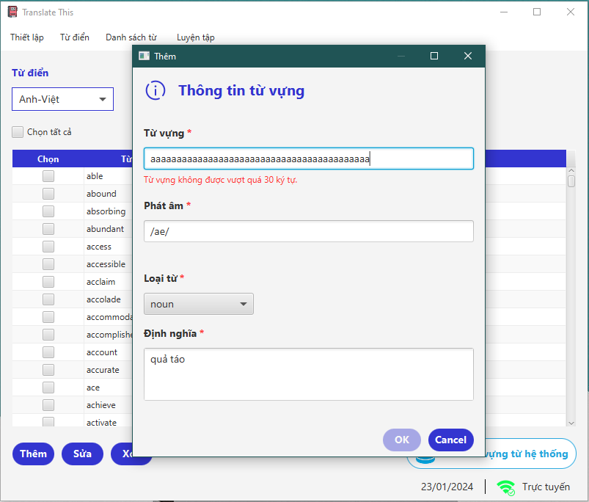

Figure 20: Check insert informations – 4

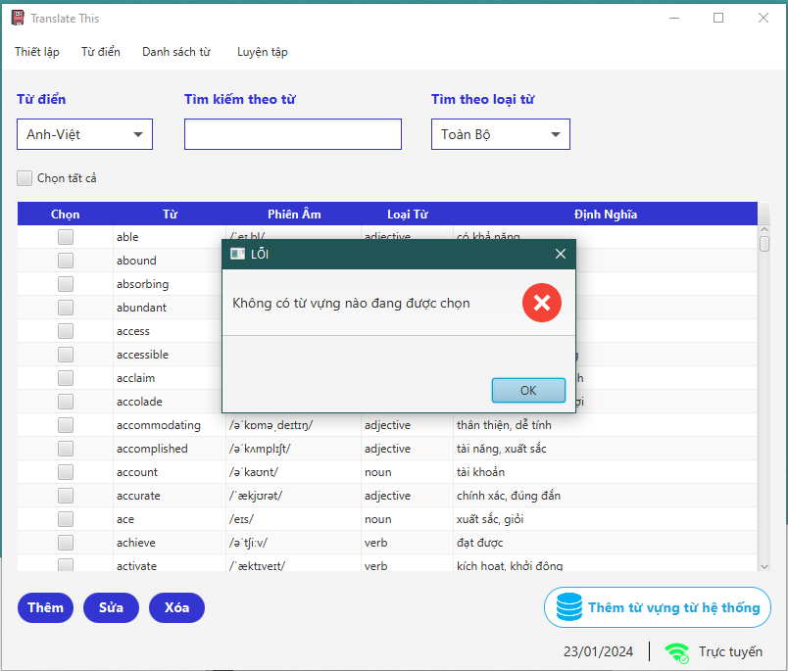

Figure 21: Edit error - 1

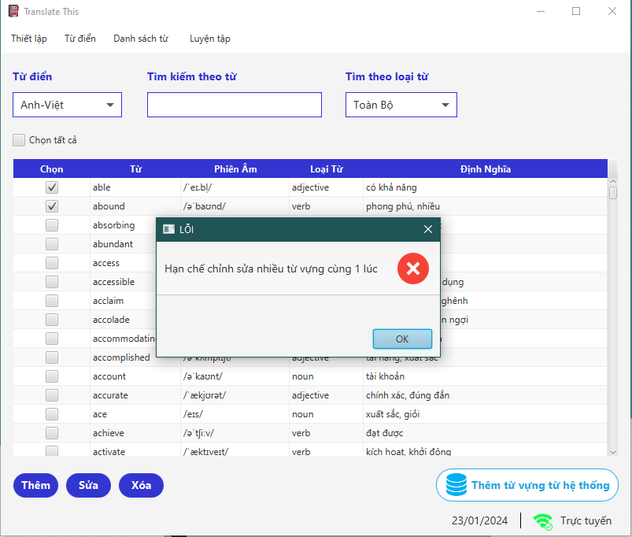

Figure 22: Edit error - 2

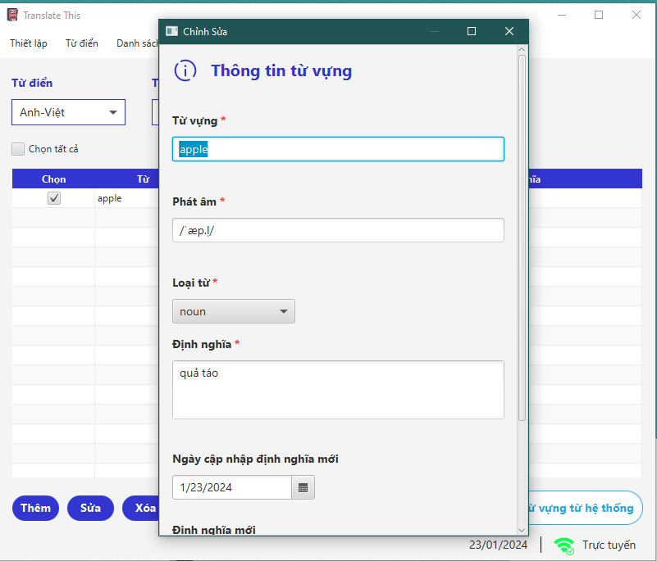

Figure 23: Edit vocabulary window - 1

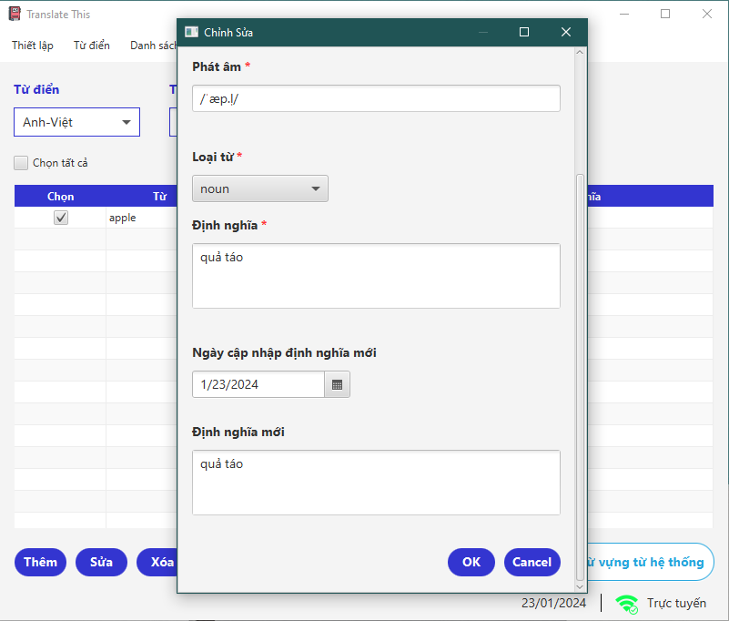

Figure 24: Edit vocabulary window – 2

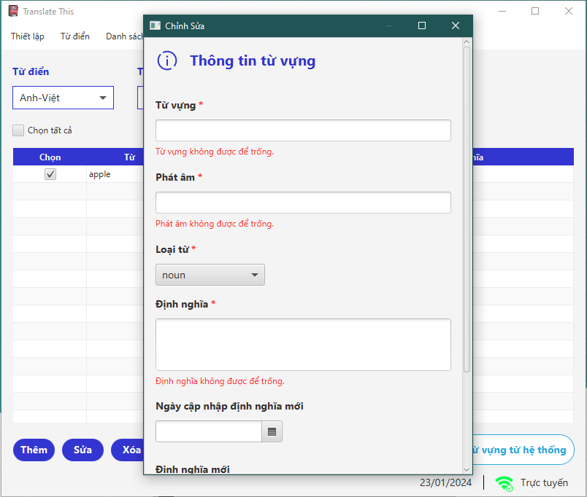

Figure 25: Check edit informations – 1

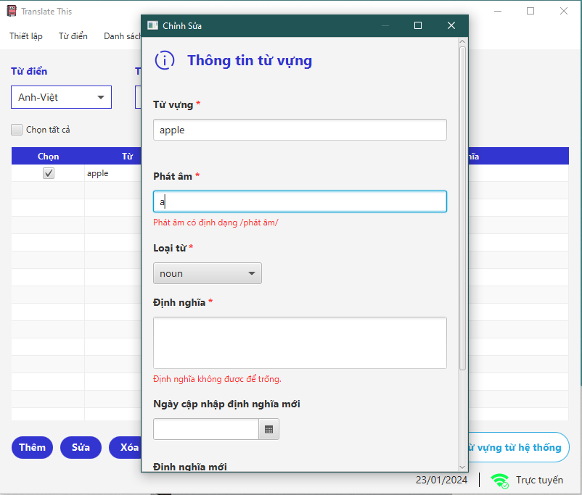

Figure 26: Check edit informations – 2

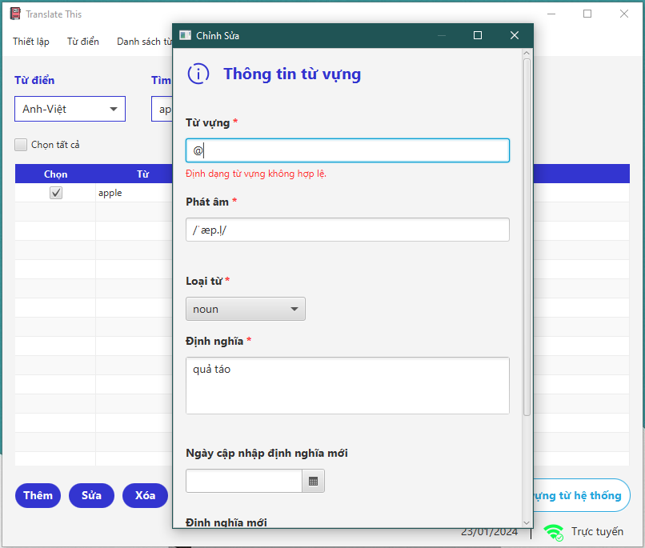

Figure 27: Check edit informations – 3

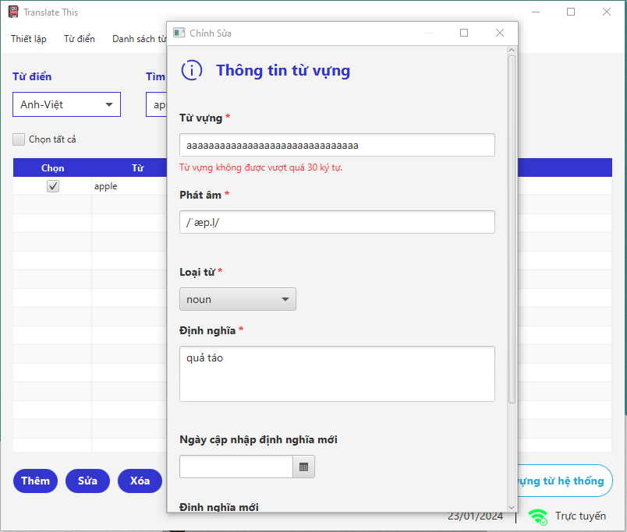

Figure 28: Check edit informations – 4

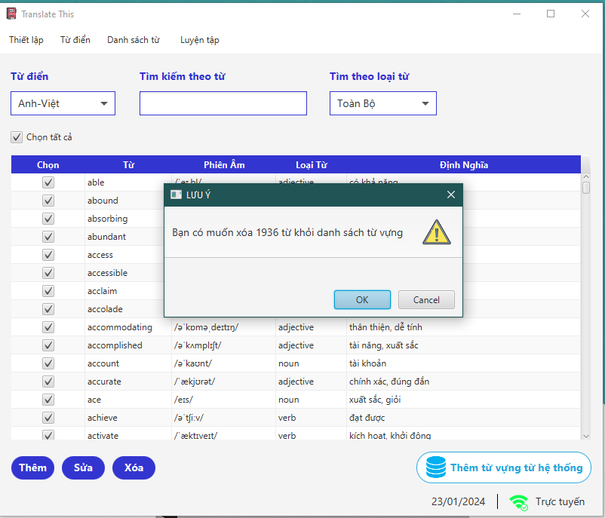

*Figure 29: Delete alert*

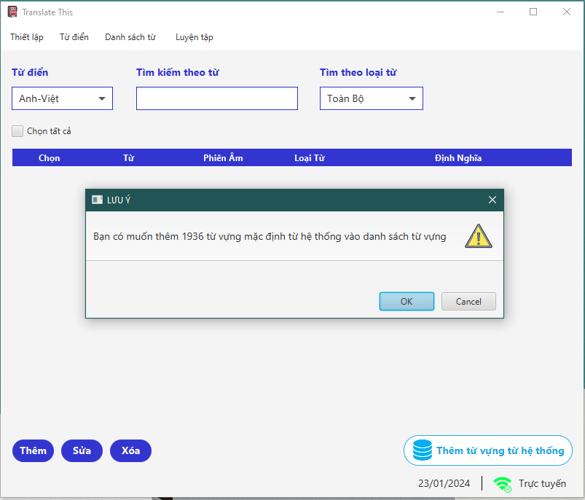

*Figure 30: Insert new vocabulary from system database to user database*

*Hangman game:*

*Game:*

1. *Display:*

* The Hangman game features a vocabulary-enhancing word guessing display, including a letter selection interface, a scoring mechanism that progresses with incorrect guesses, game status messages, and a scoreboard.

1. *Function:*

* Shows the word to be guessed with underscores for each letter.
* Displays letters A-Z for players to select and guess.
* Displaying player turns, each one progressively decreases with each incorrect guess.
* Displays messages indicating the progress of the game, such as correct or incorrect guesses, and win/lose notifications.
* Calculate and save the score based on the number of correct/incorrect guesses.

1. *Screen shot:*

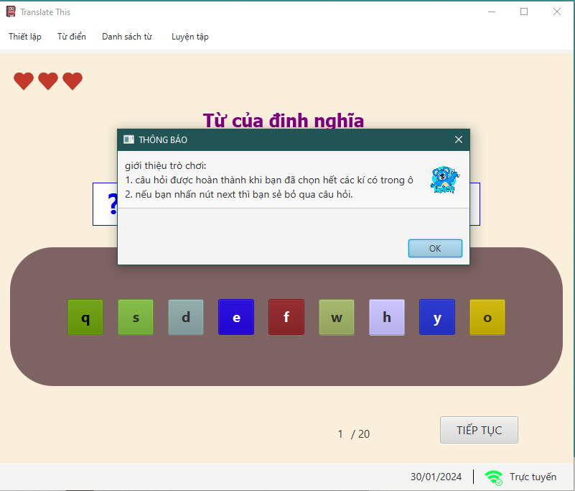

Figure 31: Hangman game -1

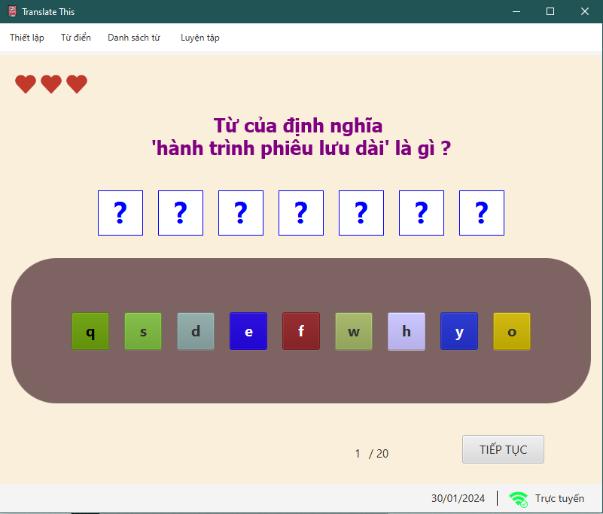

Figure 32: Hangman game -2

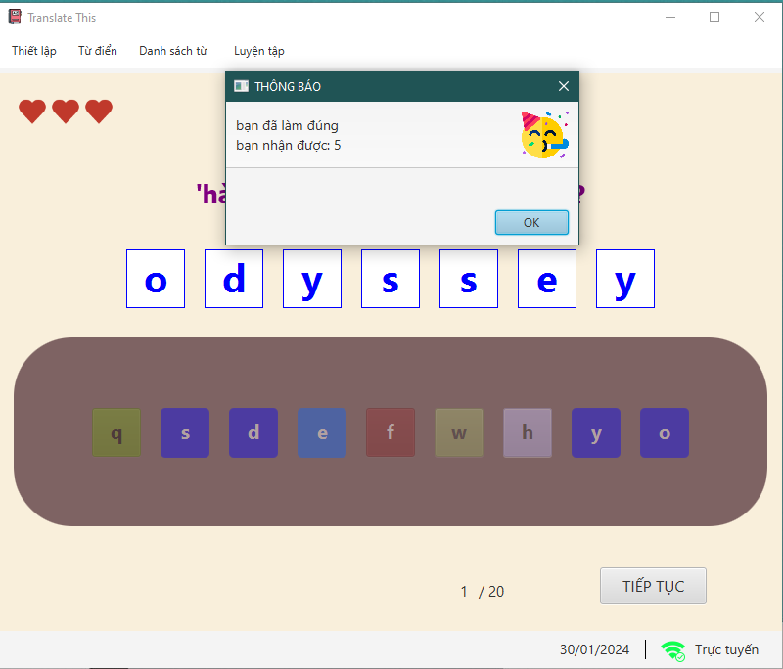

*Figure 33: Guess the entire word correctly*

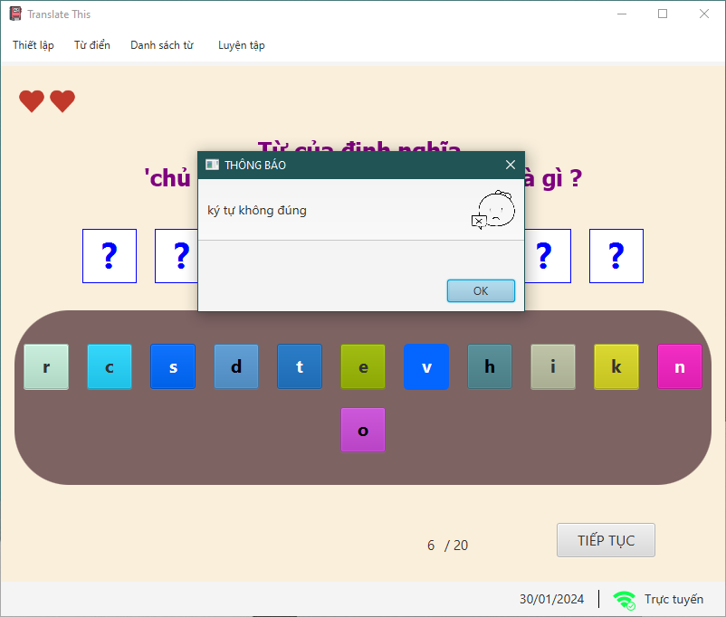

*Figure 34: Guess incorrectly*

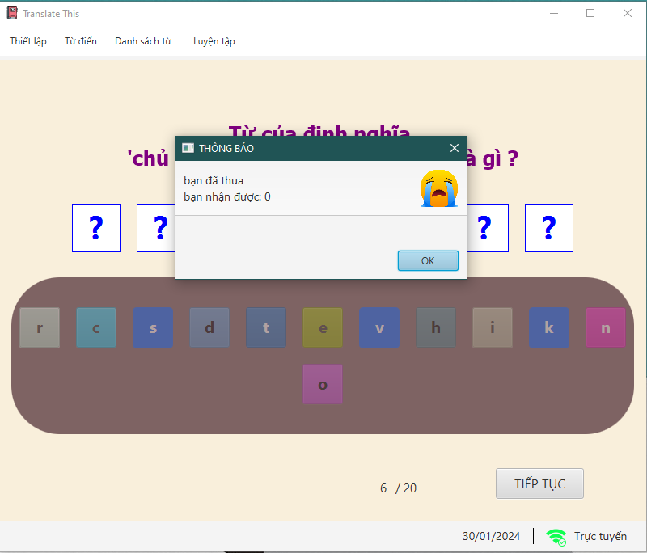

*Figure 35: Guess incorrectly three times*

*Scoreboard:*

1. *Display:*

* At the game's conclusion, scoreboard provides a summary of the performance, including the final scores, questions, answers, current scores, and other relevant statistics.

1. *Function:*

* Displays the total score, questions, answers, and score for each question, as well as other related statistics.
* Filter by score and date.
* Keep track a history of past games and performances, allowing players to review their improvement over time..

1. *Screen shot:*

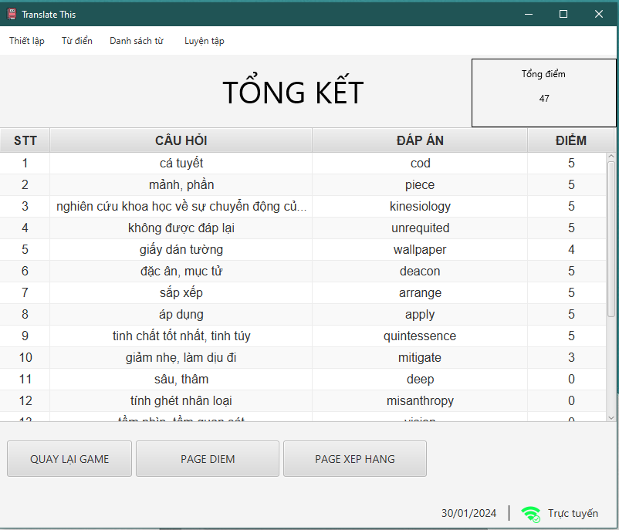

*Figure 36: Detail scoreboard*

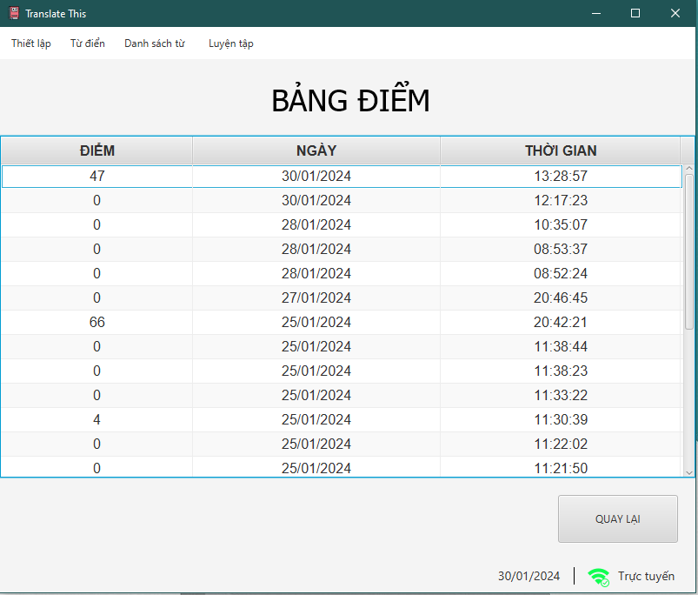

*Figure 37: Summary score board*

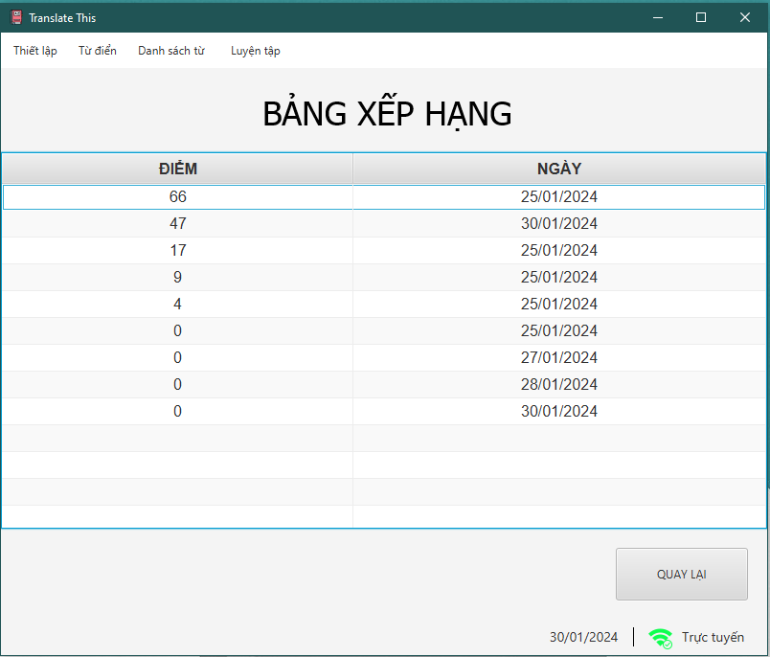

*Figure 38: Ranking score board*

## **TASK SHEET REVIEW 3**

|  |  |  |  |  |  |  |  |  |
| --- | --- | --- | --- | --- | --- | --- | --- | --- |
| **Project: Translate This** | | **Project Name** | **Activity**  **Plan Prepared**  **By** | | **Date of Preparation of Activity Plan:** | | | |
| **Sr./No.** | **Task** | **Actual Start Date** | **Actual Days** | **Team member name** | **Status** |
| 1 | Dictionary, Vocabulary data (edit, add vocabulary from default data to user data) | Translate This | Tuấn, Huy, Nhung | | 31/Dec/2023 | 30 | Tuấn | Completed |
| 2 | Vocabulary data (view, search, add, delete) | 31/Dec/2023 | 30 | Nhung | Completed |
| 3 | Hangman game | 31/Dec/2023 | 30 | Huy | Completed |
| Date: 30/Jan/2024 | | | | | | | | |
| Signature of Instructor:  Ms. LÊ MỘNG THÚY | | | | Signature of Team Leader:  VŨ MINH TUẤN | | | | |

**THANK YOU FOR YOUR READING**

In conclusion, this project has been an incredible learning journey, and we are truly grateful for the knowledge and experiences it has brought into our life. We hope that the skills we have acquired here will serve well in our future endeavors.

Once again thank you all for listening and contributing comments to our project!

**Sincerely grateful,**

**GROUP 1**